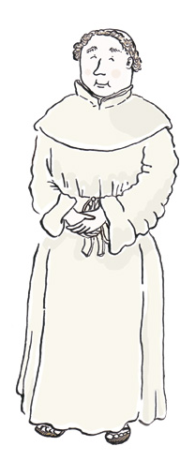
Name:_.________________________ Date:_________________
Draw and label a Tudor dinner plate
The main part of each Tudor meal was________________. Everyone by law

ate_____________on ________________. They ate raspberries and gooseberries

from_________________. They ate peppers, pumpkins and___________________from

America. They used___________________to sweeten their Food.

They drank_________________from France and Spain.
Fill in the blanks
fish wine honey potatoes Europe Fridays meat

