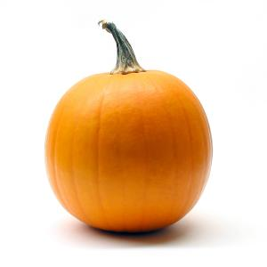
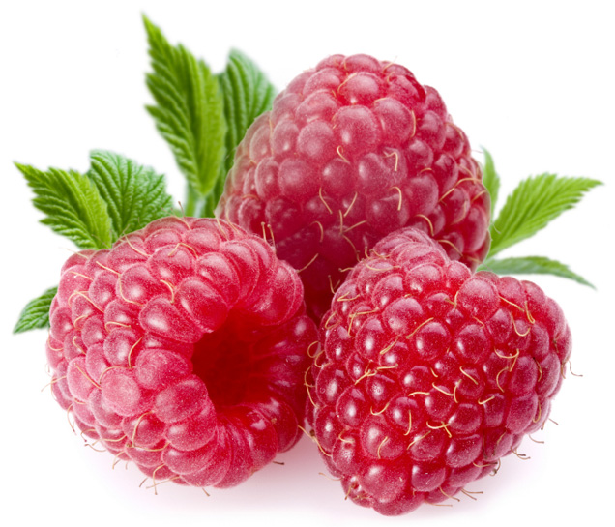
Fish
Potatoes
Pumpkin
Raspberries
Peacock
Deer
Rabbit
Swan

