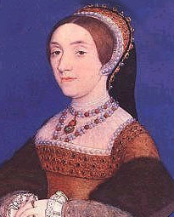
Katherine Howard
b. 1520
m. 1540
d. (ex) 1542
Katherine was the fifth of Henry’s wives and never gave birth to any children. She was executed after only two years of being married to Henry, after being found guilty of committing treason.
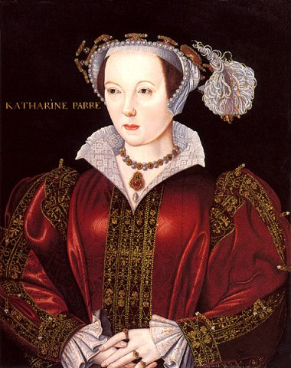
Catherine Parr
b. 1512
m. 1543
d. 1548
Catherine was the last of Henry’s six wives and the only one to survive his rule whilst being married to him. She was a strong-headed lady who is thought to have largely influenced the life of Henry’s daughter Elizabeth, later to become Queen.
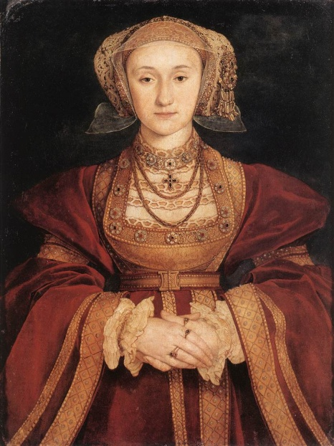
Anne of Cleves
b. 1515
m. 1540
div. 1540
d. 1557
Anne was married to Henry for a very short time. It is said that the portrait that was shown to Henry of Anne was misleading and that when he actually met Anne he thought she was ugly. The marriage was annulled just six months after.
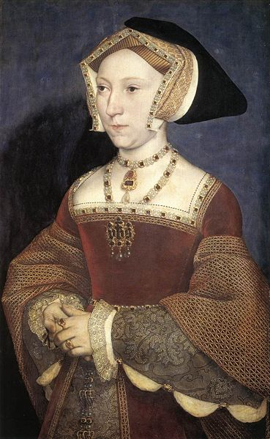
Jane Seymour
b. 1508
m. 1536
d. 1537
Jane was the third of Henry’s wives and perhaps the most beloved. Jane gave birth to Henry’s only male heir, Edward, who would one day become king. She died soon after his birth after getting ill from child birth. Henry wore black for three months after her death and is buried beside her at Windsor Castle.
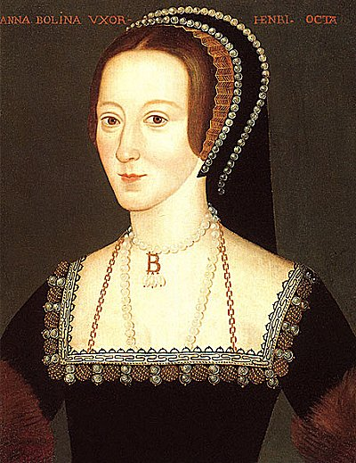
Anne Boleyn
b. 1501/1507
m. 1533
d. (ex) 1536
Anne was the second of Henry’s wives. Anne was one of Catherine of Aragon’s ladies-in-waiting and soon caught Henry’s attention. She was the reason for Henry to separate England from Rome and create the Church of England so that he could divorce and marry Anne. She was found guilty (although some still believe her to be innocent) of treason in 1536 and executed at Tower Green.
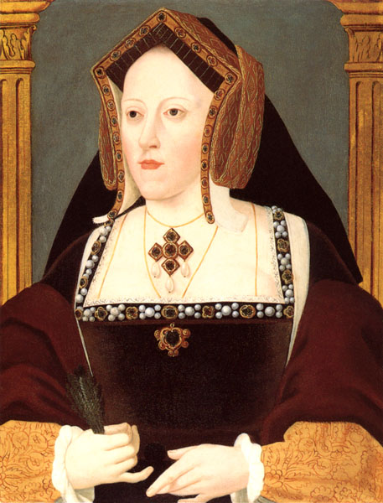
Catherine of Aragon
b. 1485
m. 1509
div. 1533
d. 1536
Catherine was Henry’s first wife, and was actually married to Henry’s brother, Arthur, who died before Henry became king. She was a devout Catholic and gave birth to Mary who one day, as Queen, would seek to return England to Catholic rule. She divorced Henry in 1533 and died 3 years later.
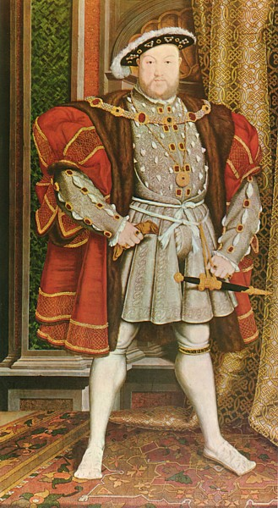
Henry VIII
b. 1491, coronation, 1509, d. 1547
Henry became king of England when his father, Henry VII, died in 1509. He is perhaps one of the most influential members of the English monarchy in history. He created the Church of England after separating from Catholicism in 1532 after the Pope would not grant him a divorce. He longed for a son to succeed his throne and many say this is why he had so many wives as so few could provide him with one. He married six times, and had three children who would go on to become Edward VI, Mary I and Elizabeth I. He died in 1547 at Whitehall in London.
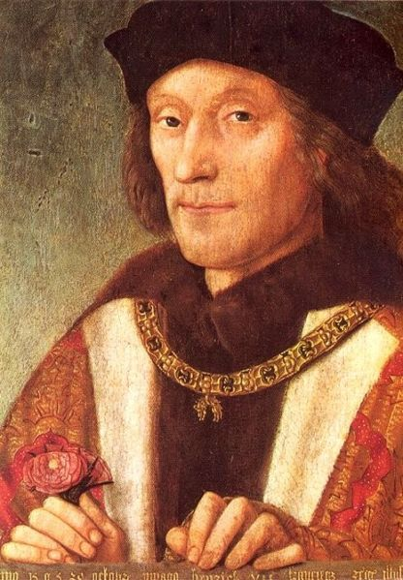
Henry VII
b. 1457, coronation. 1485, d. 1509
Henry was the first of the Tudor monarchs. He was made King after his victory over Richard III at the Battle of Bosworth, dubbed the War of the Roses. The War had raged between the Houses of Lancaster (Henry) and York (Richard) for over 30 years and when Henry became King he created what is known as the Tudor Rose, a mix of the red rose of Lancaster and the white rose of York. 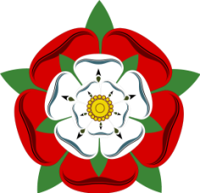The Tudor Rose
He married Elizabeth of York and they had seven children, including a son who would become Henry VIII.

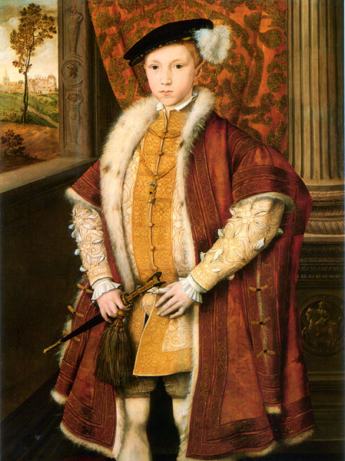
Edward VI
b. 1537, coronation 1547, d. 1553
Edward VI was the son of Henry VIII and Jane Seymour. He was crowned King at the age of just nine however his reign was to be cut short when he fell extremely ill at the age of 15. During his reign, the Protestant religion grew in England and it gained support throughout the country. On his death bed, he wanted to ensure that his Protestant legacy continued. With this in mind, he named his cousin, Lady Jane Grey as his successor. Jane only stayed Queen for nine days before stripped of her title by Edward’s Catholic half-sister, Mary.

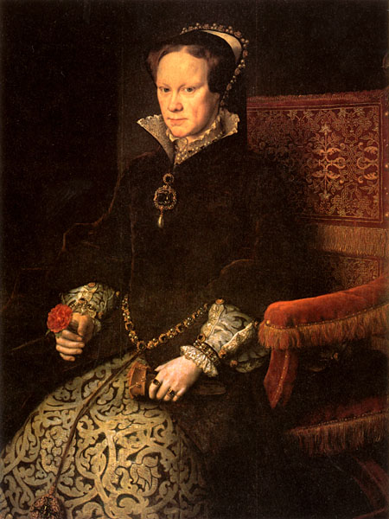Mary I
b. 1516, coronation 1553, d. 1558
Mary came to the throne shortly after the death of her half-brother Edward VI. She was the daughter of Henry VIII and Catherine of Aragon. She was, like her mother before her, a devout Catholic and sought to return England to Catholic rule. She had almost 300 Protestant supporters burned at the stake during her reign. She married Prince Phillip of Spain who was also Catholic to ensure that they gave birth to a Catholic heir. England did not have a good relationship with Spain and their marriage was criticised by many. She never gave birth to child and she died in 1558.
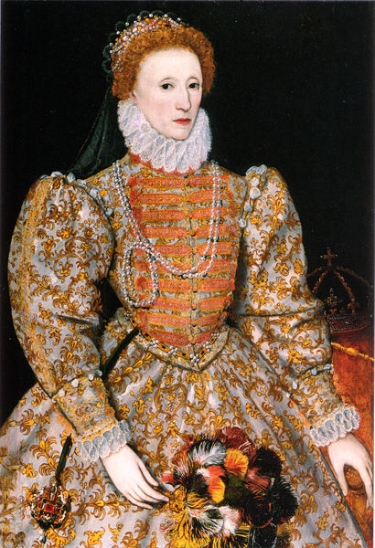
Elizabeth I
b. 1533, coronation 1558, d. 1603
Elizabeth came to the throne in 1558 after the death of her half-sister Mary I. Mary had begged Elizabeth to continue her Catholic rule, however Elizabeth maintained her Protestant faith that her father, Henry VIII had created. She is one of England’s most treasured monarchs as she ruled the ‘Golden Age’. It was so called because of events during the time; like Shakespeare’s plays, and Walter Raleigh and Francis Drake’s discoveries. Elizabeth also successfully defended England from the Spanish Armada and was a huge turning point in the turmoil with Catholic Spain. She died in 1603, and at the time was England’s longest serving monarch.

