Viking Research

Follow the link to find the answers!!!
Tip: You will need a flash player to do most of the activities.

1. Where did the Vikings mostly live on?

Link: http://www.woodlands-junior.kent.sch.uk/Homework/vikingsax.html

Answer:

------------------------------------------------------------
2. In what year did William the Conquer invade the Vikings?

Link: http://www.bbc.co.uk/schools/vikings/what_happened/index.shtml

Answer:

------------------------------------------------------------
3. What were Viking’s ships called?

Link: http://home.freeuk.net/elloughton13/travels.htm

Answer:

-------------------------------------------------------------
3. Click on Viking House then type in what’s not meant to be in the picture.

Link: http://www.bbc.co.uk/history/walk/flash/viking.html
Answer:

--------------------------------------------------------------
4. Where did Leif Erickson grow up?

Link: http://www.mnc.net/norway/LeifErikson.htm
Answer:

--------------------------------------------------------------
5. At the beginning of the Viking Age what were they the best in the world at?

Link: http://www.factmonster.com/ce6/history/A0850886.html
Answer:

--------------------------------------------------------------

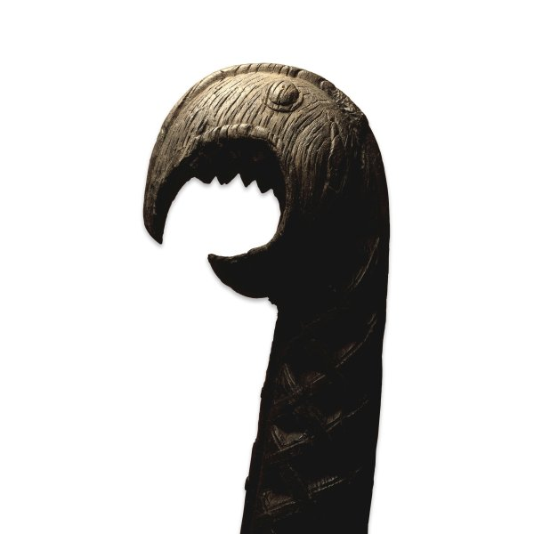
7. What position would this object be on a Viking ship?

Answer:

-------------------------------------------------------------
8. Fill in the missing words.
Link: http://www.thebritishmuseum.ac.uk/compass/ixbin/hixclient.exe?_IXDB_=compass&_IXFIRST_=1&_IXMAXHITS_=1&_IXSPFX_=graphical/full/&$+with+all_unique_id_index+is+$=OBJ3577&submit-button=summary

Iron spearhead with silver and copper decoration
Viking, late ( )-10th century AD
London, ( )
This large and elegant spearhead was found in the ( ) Thames in 1848. It formed part of the collection of the pioneering ( ) archaeologist Thomas ( ).
All free men in ( ) society was entitled to own and carry weapons: spear heads are the most commonly found weapon of the Viking ( ). Although often discovered in graves, there is much discussion about why so many weapons from ( ) period were lost or deliberately put into ( ), notably the Thames in the ( ) area.
The ( ) is slender and tapering, with a long socket. The socket is completely covered with rings of twisted silver, and ( ) wires are inlaid into the iron surface in a herring-bone pattern. This decoration is typical of the craftsmanship of the Viking smiths in Norway. One substantial rivet attached the spear head to a long wooden shaft, making an effective weapon for both ( ) and ( ).
-------------------------------------------------------------
9. First follow the link. Click design. Then type in what Viking houses’ roofs are made from.
(You will need quicktime or realplayer.)
Link: http://www.pbs.org/wgbh/nova/vikings/village.html
Answer:
--------------------------------------------------------------
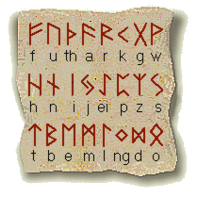
10. Type in what runes look the same in the English alphabet.

Answer:

--------------------------------------------------------------
11. Name the Five things that Captain Olaf needed and what they did for him.
Link: http://www.bbc.co.uk/schools/vikings/activities/activity.html
Answer:
--------------------------------------------------------------
12. When did the Scots drive the Vikings out of Scottish mainland?
Link: http://www.bbc.co.uk/schools/vikings/timeline.shtml

