Make a “Vindolanda Tablet” - First of all, colour (not too dark!) and cut out the “wood” below. Punch the holes and tie them together carefully.
Imagine you are a roman soldier - think of a message. You live on the edge of the world remember – what do you want from home? Are you enjoying it? Have you got any news? Remember to write neatly. http://vindolanda.csad.ox.ac.uk/index.shtml

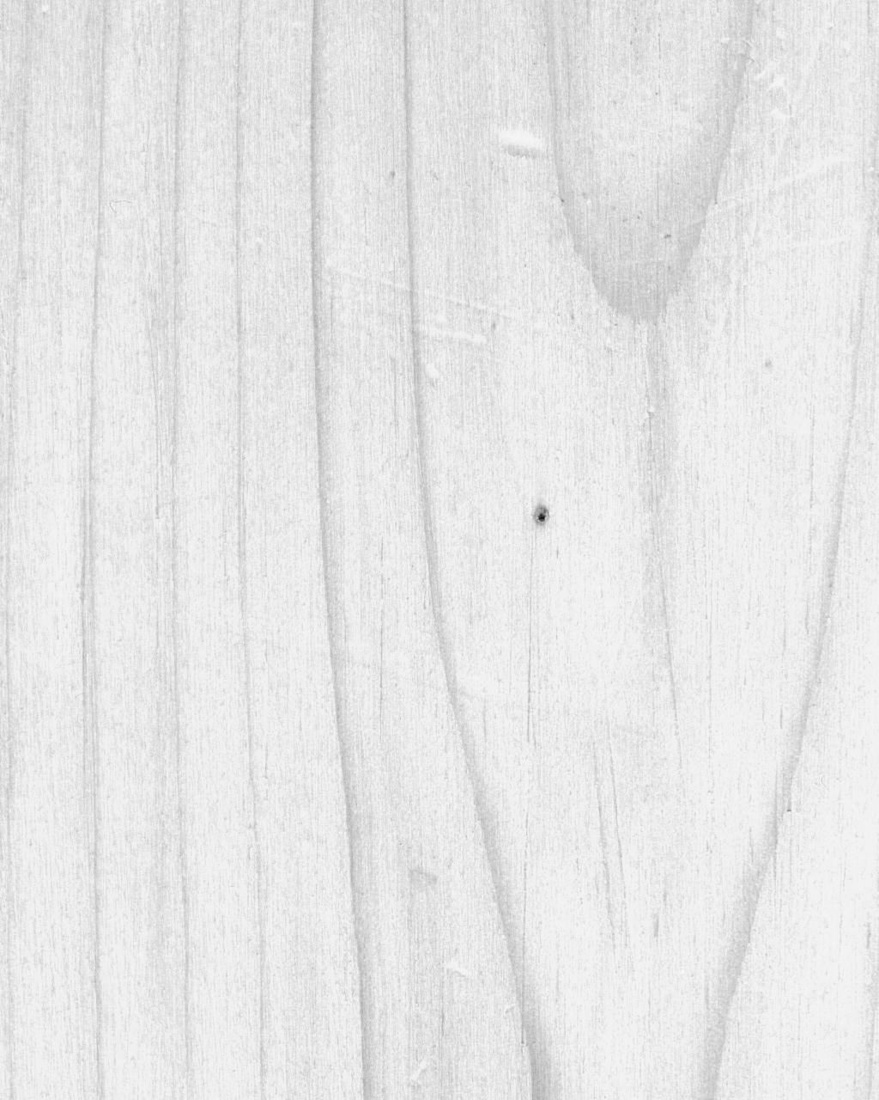

 | The Romans
 | The Vindolanda Tablets
These flat pieces of wood were found at a site called Vindolanda, now Chesterholm, close to the border with Scotland and part of Hadrian’s Wall. It was built in around 112AD – so these are almost 1900 years old! They record all sorts of ordinary matters which happened when the Romans lived at the very edge of their world. Look at the following (sometimes only part is translated from the Latin):
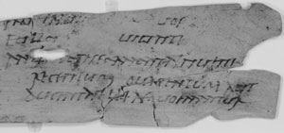
“... bruised beans two modii*, chickens twenty, a hundred apples, if you can find nice ones, a hundred or two hundred eggs, if they are for sale there at a fair price. ... 8 sextarii of fish-sauce ... a modius* of olives ...”
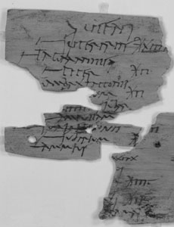
“Century of Ucenius:
overcoats, denarii 13+ …pepper, denarii 2…towel, denarii 2 …”

“….for the festival….wine, modius* 1, sextarii 12….”
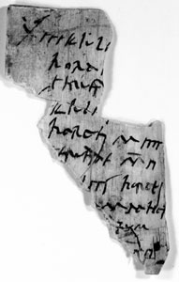

Now answer these questions:
- How many chickens? (letter 1)
- How many litres* of “bruised beans”? (letter 1)
- How much is an overcoat? How much is pepper? How much is a towel?
- How much does a modius* of wine cost?
- one modius = about 8 litres. The plural is modii (not modiuses!)
Images taken from http://vindolanda.csad.ox.ac.uk/index.shtml
Copyright British Museum

