ICT Lesson 3

Getting to know your computer.

The parts of a computer are known as the hardware.

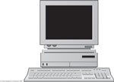

Look at this diagram of a computer. Click in the text box and type in the names for the parts of the computer.

Some parts are missing from this diagram.

Think about how you can communicate with the computer. What would you normally use? Type your answer in the next box.

There are two ways you would be able to hear sound. What would you need?
Type your answers in the next 2 boxes.

Type your name and date in this last box.

Save this work to your Good Work folder. Name the file ICT Lesson 3.
Ask the teacher if you can print your work today. EPScott2005

