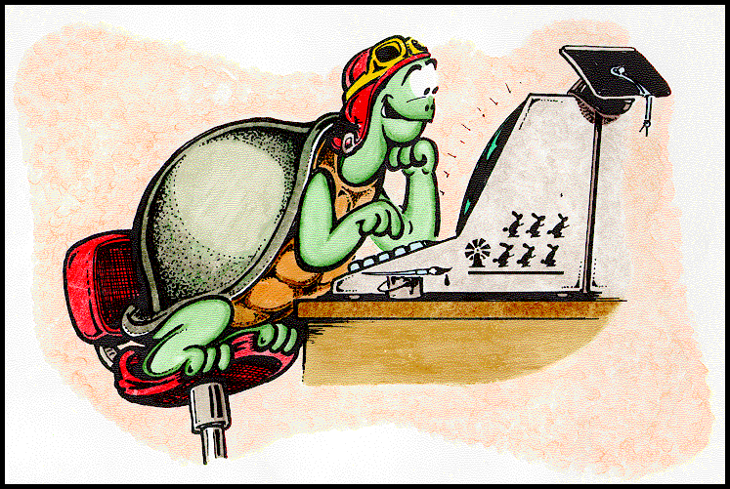
Can you match up the full text with the logo shorthand? Draw lines to show the meanings.

FD clear screen

BK clear graphics

RT pen down

LT forward

PU clear text

PD left

CS right

CG show turtle

HT back

ST hide turtle

CT pen up

Logo Lingo Bingo
Write one of the shorthand instructions into each box on one strip. Cross them off as the full versions are read out by your teacher.

