 | World Wide Web  Task 1  

1. Open Microsoft Internet Explorer: | 

2. Type the website address below in the ‘Address’ box:
www.symbolworld.org/eLive

3. Click on the Go button or press the Enter key: | or 

4. Click on View Online: | 

5. Add this website to your ‘Favourites’ list: | 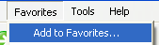

6. Click on NEWS: | 

7. How many news stories are there? | ?

8. Write down the name of a news story: | ?

9. Click on the hand pointing left to go back a page: | 

10. Click on the hand pointing right to go forward a page: | 

11. Click on FILMS: | 

12. How many film reviews are there? | ?

13. Write down the name of a film review: | ?

14. Click on a different part, such as FUN: | 

15. Close Microsoft Internet Explorer:

World Wide Web
Task 1


1. Open Microsoft Internet Explorer:

2. Type the website address below into the Address box:
www.jigzone.com

3. Click on the Go button or press the Enter key: | or

4. Add this website to your
Favourites list:

5. Choose a Puzzle and the number of pieces: | 

6. Choose the number of pieces, such as 6 Piece Classic:

7. Click on the Back button to go back a page: | 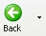
 | World Wide Web | 

1. Open Microsoft Internet Explorer:

2. Type the website address below into the Address box:
www.emailsanta.com

3. Click on the Go button or press the Enter key: | or

4. Type in your first name and click on Click!: | 

5. Click on a stamp, such as Rudolph: | 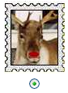

6. Choose whether you are a boy or girl and fill-in all the boxes: | 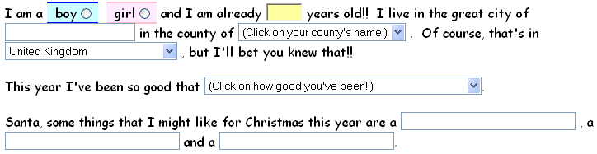

7. Click on a treat for Santa and his reindeer, such as Goodies to Eat: | 

8. Click on Send Santa Claus my letter!:

 | World Wide Web  Task 1   | 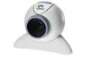

1. Open Microsoft Internet Explorer:

2. Type the website address below in the ‘Address’ box:
www.earthcam.com

3. Click on a webcam: | 

Extension activity:

Which webcams did you look at?

Name of webcam: |  | Score out of 10:

World Wide Web
Task 1

1. Open Microsoft Internet Explorer:

2. Type the website address below into the Address box:
www.80smusiclyrics.com | 

3. Click on the Go button or press the Enter key: | or

4. Click on ‘80s Arcade Games:

5. Find a game, such as Pacman: | 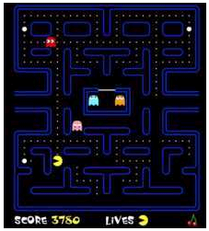

6. Click on Click Here to Play:

7. Click on PLAY GAME:

