 | World Wide Web  Ultimate Flash Face

1. Open Microsoft Internet Explorer: | 

2. Type the website address below in the ‘Address’ box:
http://flashface.ctapt.de

3. Click on the Go button or press the Enter key: | or 

4. Add this website to your ‘Favourites’ list: | 

5. On the Ultimate Flash Face website click on a part of the face, such as Hair: | 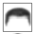

6. Click on a type of hair, such as number 15: | 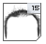

7. Click on another part of the face, such as Head: | 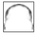

8. Click on a type of head, such as number 3: | 

9. Click on other parts of the face until you have made a face: | 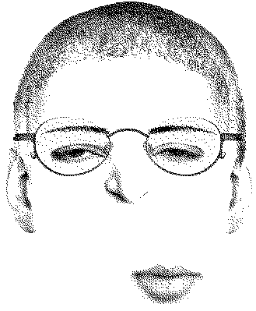

10. Use click and drag to move around parts of the face: | 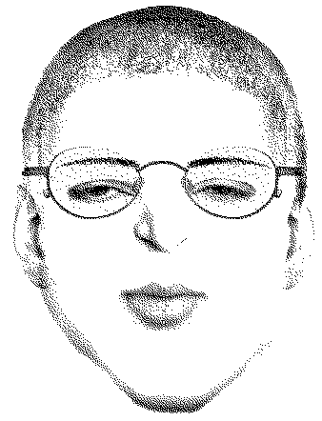

Extension activities:

- Make the face of your teacher.
- Make the face of a friend.
- Make the face of a famous person.

11. Close Microsoft Internet Explorer:

World Wide Web
Task 1


1. Open Microsoft Internet Explorer:

2. Type the website address below in the ‘Address’ box:
www.symbolworld.org | 

3. Click on the Go button or press the Enter key: | or

4. Click on eLive: | 

5. Click on View Online: | 

6. Add this website to your ‘Favourites’ list:

7. Click on NEWS: | 

8. How many news stories are there? | ?

9. Write down the name of a news story: | ?

10. Click on the hand pointing left to go back a page: | 

11. Click on the hand pointing right to go forward a page: | 

12. Click on FILMS: | 

13. How many film reviews are there? | ?

14. Write down the name of a film review: | ?

15. Click on a different part, such as FUN: | 

16. Close Microsoft Internet Explorer:

World Wide Web
Task 1


1. Open Microsoft Internet Explorer:

2. Type the website address below into the ‘Address’ box:
www.graffiticreator.net

3. Click on the Go button or press the Enter key: | or

4. Click on a Load Font button:

5. Type a word, such as your first name, into the empty box: | 

6. Click on Create: | 

7. Change the colours of your word: | 

8. Change the width, height and rotation of your word: | 