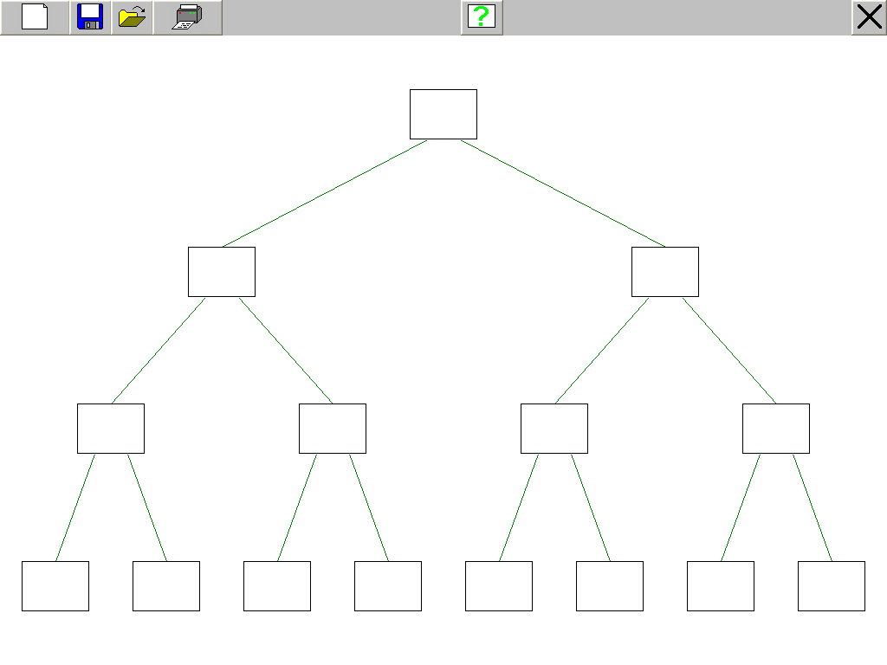

Name……………………………………………

Branching Database

