Highlight the text first

Then either…..

- Edit > copy
OR
- hold down ctrl and C keys together
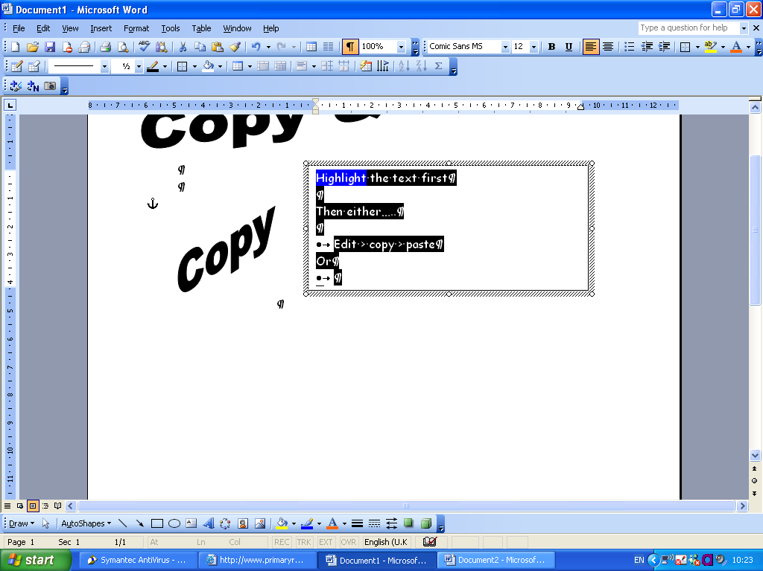
OR
- Use the copy icon
Then

- Edit > paste
OR
- Hold down cntl and V keys together
OR
- Use the paste icon

