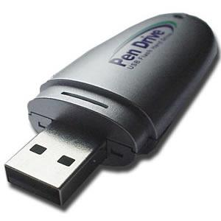 | Insert, remove, label and store  media safely | 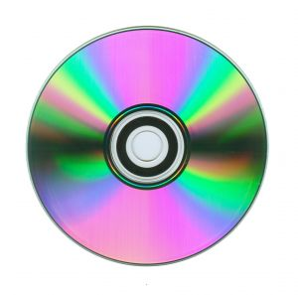

Computer files can be stored separately from a computer on portable storage media.
1. | Name three types of portable storage media:
2. | CD-Rs and DVDs are read-only. Is this True or False?
3. | Flash drives and hard disks are read–write. Is this True or False?
4. | Name three ways that you can label a CD or DVD disc:
5. | What happens if a CD disc is loaded into the drive the wrong way up?
6. | What has replaced the floppy disk?

Insert, remove, label and store
word search

h | o | c | u | u | k | l | u | v | e | e | u | a | r | g
y | s | i | s | e | n | b | d | q | b | w | g | d | e | w
m | s | c | b | k | d | h | f | i | z | w | v | v | q | v
l | d | v | f | z | y | y | r | e | a | d | o | n | l | y
m | b | u | l | c | g | c | t | i | d | i | r | k | y | q
r | c | n | a | n | s | i | g | i | z | j | s | v | b | n
x | c | b | s | t | r | i | s | k | e | i | x | c | c | t
h | r | o | h | w | x | c | d | r | d | i | s | c | n | m
d | p | g | d | e | g | r | m | y | j | h | w | k | i | n
z | i | a | r | q | b | o | p | t | a | d | j | j | k | g
l | e | q | i | e | i | p | f | g | v | r | z | h | w | t
r | l | v | v | x | o | u | w | w | w | z | u | o | q | q
l | a | b | e | l | w | q | h | f | r | r | y | l | v | f
f | a | w | f | m | l | p | p | c | k | i | r | j | b | j
j | e | j | g | q | v | e | p | l | k | w | n | b | m | z

The words below are to do with inserting, removing, labelling and storing computer files. Can you find them all in the word search?

- Bluray disc | - CDR disc | - DVD disc
- Floppy disk  - Read only | - Label  - Read write | - LightScribe  - USB flash drive

