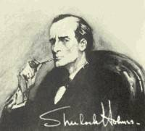
2. Sherlock Holmes and Doctor Watson lived at 221b Baker Street between 1881-1904
3. M.R.I., Shield, Hack, Field
4. He's The Best
He's The Greatest
He's The Greatest Secret Agent In The World!
He's The Ace - He's Amazing...
He's the Strongest... He's The Quickest.... He's The Best!

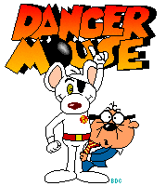
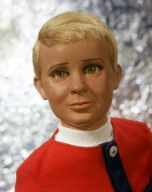

6. World Intelligence Network
7. Ian McClaine
8. 55 years old
9. Double Agent

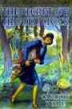
10. A girl detective
13. Freddie Jones, Velma Dinkley, Shaggy Norville, Daphne Blake
14. Morocco Mole

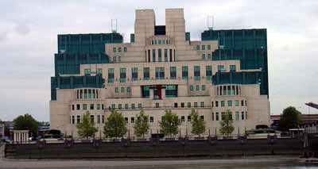
15. Secret Intelligence Service – James Bond

Sharon Sweeney

