Can you match the shape with its name?

Can you do it in less than a minute?

Can your friend do it, too?

square |  | pentagon
circle |  | triangle
octagon |  | rectangle
rhombus |  | semi-circle
hexagon |  | heptagon


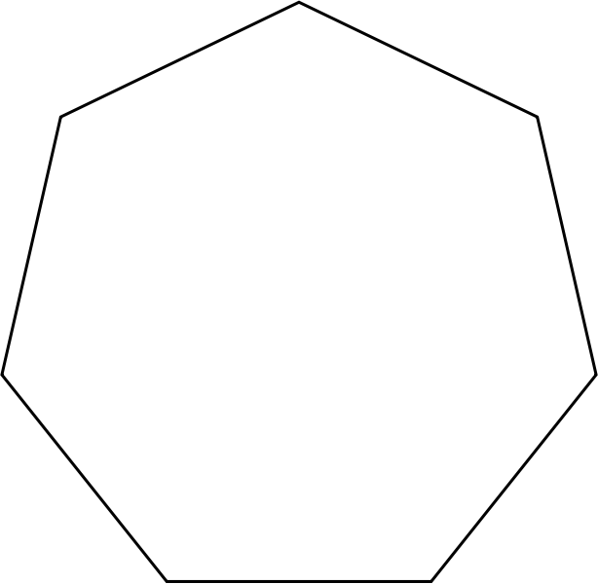

Can you put these shapes in order of the number of their sides?

Win a merit point!
Can you find out what a
9 sided shape is called?
What about a 10 sided shape?

