Lesson Objective: to understand Kg and g.

1) Erica and her friends wanted to bake a birthday cake for their friend. They needed 2.5kg of sugar for the recipe. Sarah has 1.3kg of sugar, Tom has 1400g. How much sugar did they need to buy to have enough?
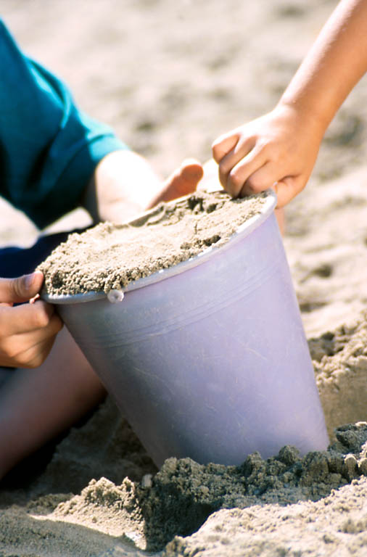
2) Stephen needed 3kg of sand for his cement mix. He only had 1.8kg. When carrying the bucket he dropped it and spilt another 0.7kg. How much does he need to order to have enough?

3) Claire wanted to post a parcel to her friend Rose. She only has enough money to post a 1.5kg parcel. She has included in the box a 400g bar of chocolate, a 150g bag of sweets, 2 packets of biscuits which weighed 30g each and a cake which weighed 850g. The parcel was weighed at her post office. It weighed 1522g. She had forgotten to weigh the box! How much did the box weigh?
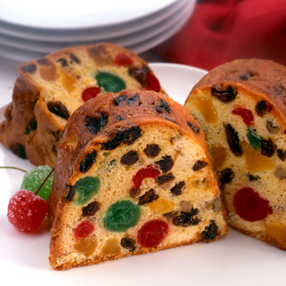
4) Linda bought a 2.4kg fruit cake. Tommy came in and cut the cake in half. He took away half to share with his friends. Then Paul came in and cut himself a slice. Linda came home and saw how much cake she had left. She decided to weigh it. The cake now weighed 900g. How much had Paul’s piece weighed?

5) Rachel bought a 2.5kg jar of chocolate peanuts for her Mum. She put the jar on the table and went into the kitchen. Then she heard bang and went to investigate. The cat had knocked the jar over and the sweets had spilt all over the floor. She picked up the jar and threw away the spilt sweets. She then had to go to the shops to buy some bags of chocolate peanuts to refill the jar. She bought 3 bags with 225g in each and used half of them to fill the jar. What was the weight of the peanuts that were thrown away?
