2D Shapes Word Mat

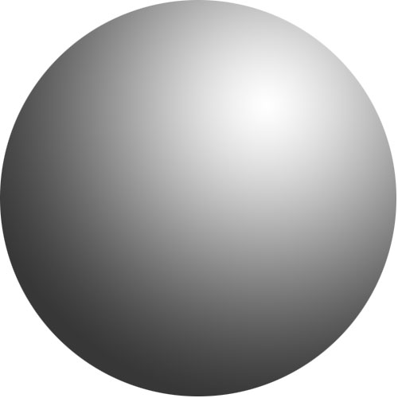
3D Shapes Word Mat

