7 sides
7 Corners

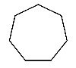
Heptagon

4 sides
2 parallel sides
4 corners

Parallelogram
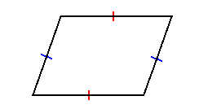

5 sides
5 Corners

Pentagon

6 sides
6 Corners

Hexagon

3 sides of equal length
3 corners

Equilateral Triangle

8 sides
8 Corners

Octagon
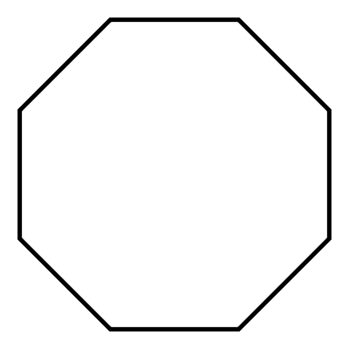

4 sides of equal length
4 corners

Square

4 sides
Opposite sides of equal length
4 corners

Rectangle

