How many?

_____
How many?

___
How many?

____
How many?

___
How many?
____
How many?

___
How many?
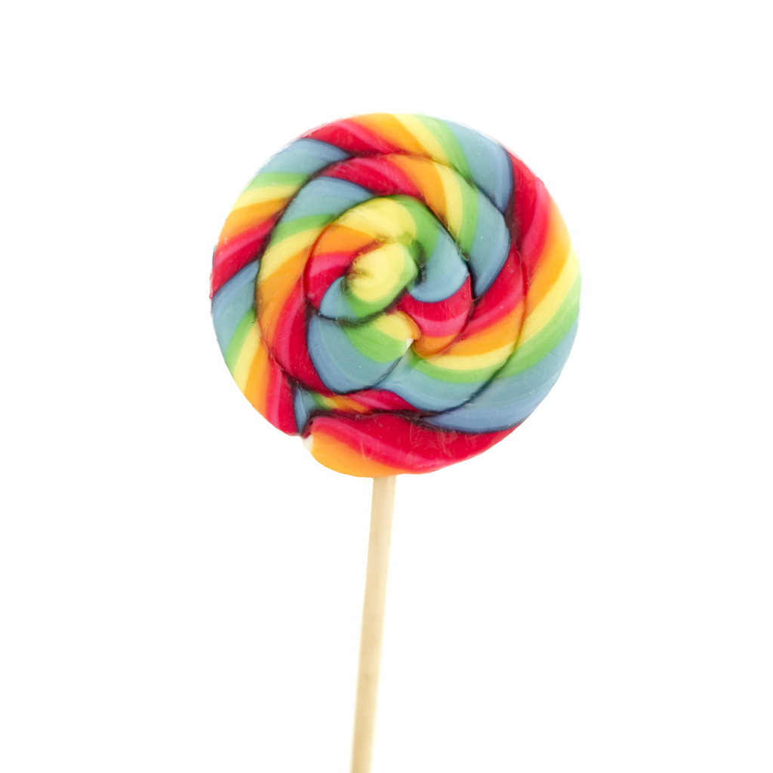
How many?
__


How many?
How many?
____

