
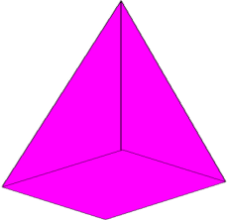
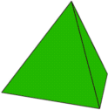
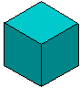
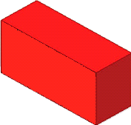
A
mATCH tHE nETS
B
C
D
E
F
G
Can you match the correct net with its 3D shape?
1
5
4
3
2
A
mATCH tHE nETS
B
C
D
E
F
G
Can you match the correct net with its 3D shape?
1
5
4
3
2

Net | Shape

Net | Shape

