Challenge!
Investigating Right Angles

Sort the quadrilaterals into a table like this.

0 right angles | 1 right angle | 2 right angles | 3 right angles | 4 right angles

A
B

C

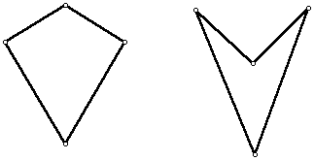
Now investigate these statements. Which are true?

All quadrilaterals have 4 right angles
All quadrilaterals have at least one right angle
All irregular quadrilaterals have no right angles.
D
D
E
F

G

II
J

L

