Scaling Quantities

Read the ingredients list for cheese scones. Scale the quantities up and down to make more or less.
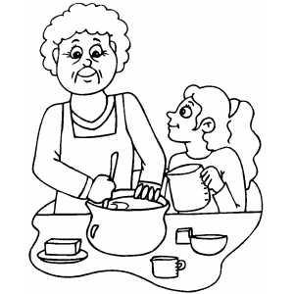
This makes about 10 scones.

220g self raising flour
25g caster sugar
50g cheese
60g butter
120ml milk

How much flour would I need to make 20 scones?
How much sugar would I need to make 20 scones?
How much cheese would I need to make 5 scones?
I want to make 30 scones for a party. How much milk will I need?
For the same party, how much butter will I need?
How much cheese will I need to make 5 scones?
If I have 60ml milk, how many scones can I make?
If I have 100g caster sugar, how many scones can I make?
If I have 250g cheese, how many scones can I make?
I only want two scones, how much flour will I need?

Write out a new ingredients list which will make 40 scones.

Scaling Quantities

This makes about 10 scones.

220g self raising flour
25g caster sugar
50g cheese
60g butter
120ml milk

Scale the quantities in the recipe up or down to make the new amounts of scones. Complete the chart with the new quantities.

Ingredients | Two | Thirty | Fifteen | Twelve | Eight
Flour
Sugar
Cheese
Butter
Milk

If I have 120g butter, how many scones can I make?

If I have 250g cheese how many scones can I make?

If I have 550g flour how many scones can I make?

Scaling Quantities

Scale the quantities in the recipe up or down to make new amounts of scones.
This makes about 10 scones.

220g self raising flour
25g caster sugar
50g cheese
60g butter
120ml milk

Show the quantities needed to make 15, 2, 8, 25 and 14 scones.

Create a table in your book to show the information and new quantities.

Scaling Quantities

Scale the quantities in the recipe up or down to make new amounts of scones.
This makes about 10 scones.

220g self raising flour
25g caster sugar
50g cheese
60g butter
120ml milk

Show the quantities needed to make 15, 2, 8, 25 and 14 scones.

Create a table in your book to show the information and new quantities.

