Smarties Mathematics Challenge – Autumn 2007

LO To answer questions by collecting, organising and interpreting data using frequency tables and bar charts to represent results.
To use estimation with a good degree of accuracy.

Before we start this investigation we must always wash our hands for reasons of hygiene. Only use the lollipop stick to move the beans around on the paper towel, any touched beans must be removed.

Task 1

- With your talking partner take it in turns to hold the tube of Smarties in one hand. Estimate what you think the weight might be in grams ………………g.

- Weigh your tube with your partner to see how much it actually weighs……….…g.
Was your estimation accurate? Yes/ No

- Tip the tube up onto a clean piece of kitchen towel. Remember you must only move the sweets around with the lollipop stick – do not touch them!

Estimate how many Smarties were in your tube. ………………………….

Now with your talking partner count how many there actually are…………….

Was your estimation accurate? Yes/ No

If you were to share them equally between your talking partner and yourself
how many would you each get? ……………………………..

Task 2

Carefully move the beans to sort them into their colour groups on the kitchen towel with the lollipop stick. Record your results on this frequency table.

Frequency table showing………………………………………...…………………….
…………………………………………………………………………………………….

Colour | Tally of beans | Total
Red
Yellow
Blue
Green
Purple
Total Number

Now create a Bar chart on squared paper using the information from your Frequency Table.

Things to remember when creating your bar chart;
- A title
- A key if it needs one
- Labels for the x (across) and the y (up) axis
- Mark the steps on the axis clearly

Task 3

If you put the beans end to end how far do you think they will stretch? ………………cm

How far did they stretch? …………………………

How many sides does the Smartie container have?
…………………………………………………………………………………..
What is the name of a 3-D shape with …………….. sides?
…………………………………………………………………………………..

Extension
Investigation
Measure one bean …………..g
Estimate how many it would take end to end to be as tall as Mrs Westlake.
………………………………………

How many did it take? …………..

Mrs Westlake is …………cm tall.

Can you think of another investigation to challenge the class with?
…………………………………………………………………………………………..
…………………………………………………………………………………………..
…………………………………………………………………………………………..
…………………………………………………………………………………………..

Teacher’s notes

The children have talking partners to work with sharing one tube of Smarties between two.

They use the same tube for each lesson so it is as well to put names or initials on the base of the tube.

Remind the children that they must wash their hands before the lesson and discard any contaminated beans – that is any that touch the table, hands etc.

Beans should be manipulated with a clean lollipop stick (putting a cross as the holding end helps) on a clean piece of paper towel.

Once the investigation is over the beans may be shared between the partners, wrapped and taken home for permission to eat them to be obtained. Hence the need to be hygienic throughout.

There are plenty of opportunities here for using the work created for a classroom display for Maths Week etc.

My example of the classroom display follows

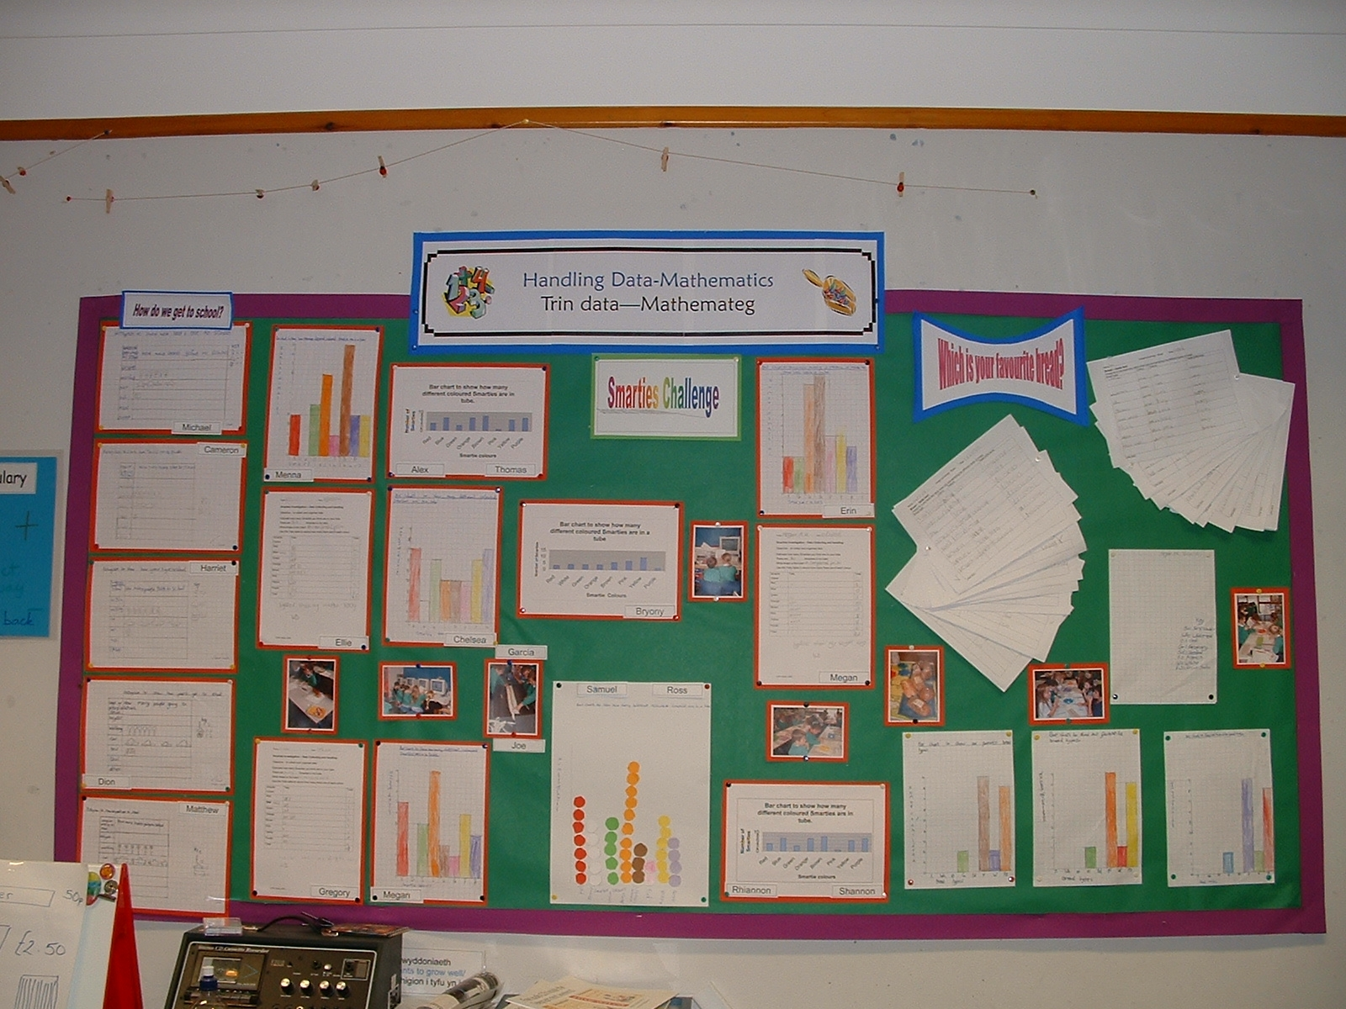

The most common colour was .........

