Toy Shop

2p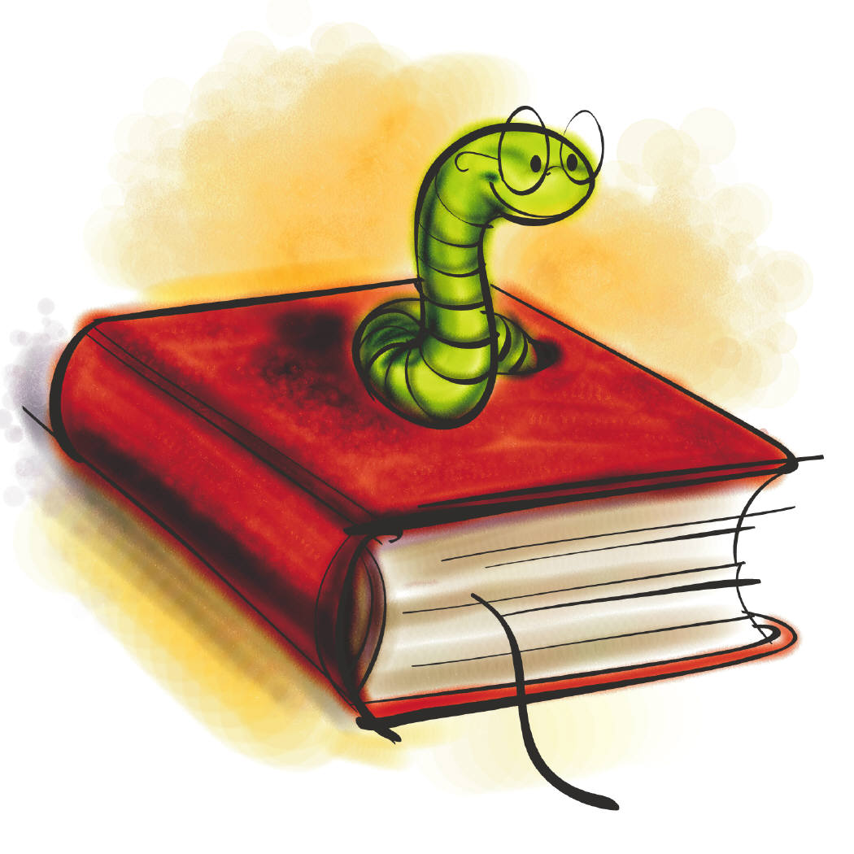 3p

4p 6p

5p
1p

Name: Date:

Toy Shop

How much would it cost for a book and a bike?

2p + 6p =

How much would it cost for a doll and a puzzle?

4p + 1p =

How much would it cost for a teddy bear and a ball?

5p + 3p =

How much would it cost for a bike and a puzzle?

6p + 1p =

Toy Shop

6p 7p

8p 10p

9p
5p

Name: Date:

Toy Shop

How much would it cost for a book and a bike?

6p + 10p =

How much would it cost for a doll and a puzzle?

8p + 5p =

How much would it cost for a teddy bear and a ball?

9p + 7p =

How much would it cost for a bike and a puzzle?

10p + 5p =

Toy Shop

11p 12p

13p 15p

14p
10p

Name: Date:

Toy Shop

How much would it cost for a book and a bike?

+ =

How much would it cost for a doll and a puzzle?

+ =

How much would it cost for a teddy bear and a ball?

+ =

How much would it cost for a bike and a puzzle?

+ =

