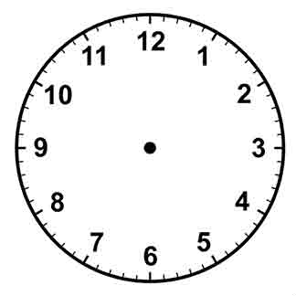 | A quarter past 1
 | A quarter to 5
 | A quarter past 7
 | A quarter to 5
 | A quarter past midnight
 | A quarter past 10
 | A quarter to 11
 | A quarter past 7
 | An hour later than a quarter past 11
 | An hour earlier than a quarter to 8
 | An hour earlier than a quarter past 6
 | Half an hour earlier than 5 O Clock
 | Half an hour earlier than half past 3
 | Half an hour later than half past 11
 | Half an hour earlier than quarter past 8
 | Half an hour later than quarter past 8

