Adding Money

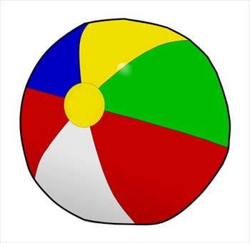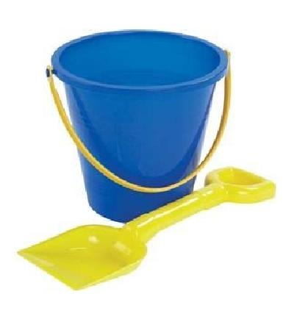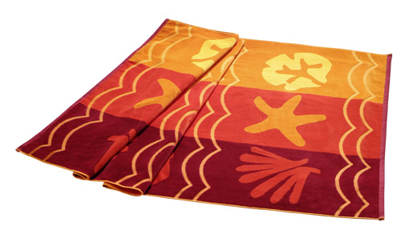
Beach ball £2.99 Bucket and spade Beach towel
£4.47 £6.25

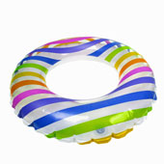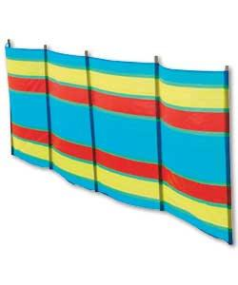
Ice cream Rubber ring Wind break
99p £5.62 £18.79

A group of children buy the following items...

- A beach ball, bucket and spade and beach towel.
- An ice cream, rubber ring and wind break.
- A bucket and spade, ice cream and beach towel.
- A beach ball, rubber ring and wind break.
- A beach towel, ice cream and rubber ring.
- A bucket and spade, rubber ring and beach ball.
- A beach towel, rubber ring and wind break.
- An ice cream, bucket and spade and beach ball.

Use rounding to estimate approximately how much each set of items cost then use the vertical addition method to work out an accurate price.

ANSWERS…
- £13.71
- £25.40
- £11.71
- £27.40
- £12.86
- £13.08
- 30.66
- £8.45

