Garden centre Price List

Sunflower 10p Poppy 20p
Rose 30p Bluebell 40p
Lily 50p Daffodil 60p
Tulip 70p Small pots 80p
Large pots 90p

I can add multiples of 10 mentally / using equipment
I can work out problems involving money
Work out the cost of buying these things from
Thornaby Garden Centre

I want to buy: | Total Cost
a sunflower and a rose
a bluebell and a poppy

a daffodil and a rose

a small pot and a sunflower

a lily and a poppy

2 roses

2 bluebells

Now choose 2 of your own plants and work out the total cost. Write a number sentence to show your working out.

I can add multiples of 10 mentally / using equipment
I can work out problems involving money HAA
Work out the cost of buying these things from Thornaby Garden Centre
I want to buy: | Total Cost  (show your working out)
a lily and a bluebell
2 poppies

a rose and a small pot
a large pot and a daffodil
A daffodil, a poppy and a sunflower
2 large pots
2 small pots and a rose
Now choose 3 of your own plants and work out the total cost. Write a number sentence to show your working out.
I can subtract multiples of 10 mentally / using equipment
I can work out problems involving money LAA/ LA
Shopping at Thornaby Garden Centre
I buy | Change from £1 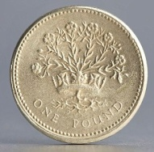
A bluebell
A tulip
A small pot
A rose
2 sunflowers
A poppy and a sunflower

A large pot and a sunflower

I can subtract multiples of 10 mentally / using equipment
I can work out problems involving money HA
Shopping at Thornaby Garden Centre
I buy: | Change from £1
A bluebell
A poppy and a lily

A large pot and a sunflower
2 poppies

A daffodil and a rose
I buy: | 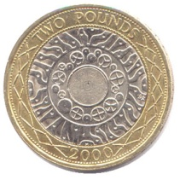Change from £2
A rose and a poppy

A large pot

A bluebell

3 sunflowers

