Name _________________________ Date _____________________
7
4
=
+

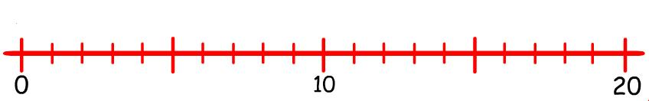

8
4
=
+

9
5
=
+

7
3
=
+

7
6
=
+

6
6
=
+

8
7
=
+

8
5
=
+
9
4
=
+
7
5
=
+

