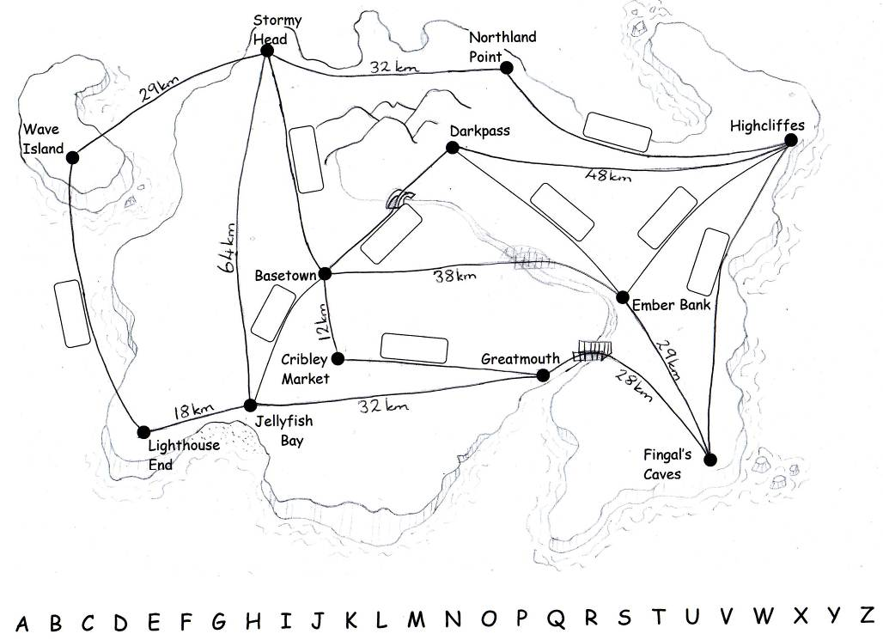

15.2.11

Obj: I can solve simple word problems involving measures.
I know whether to add or subtract to solve problems.

- The distance from Cribley Market to Greatmouth is double the distance from Basetown to Cribley Market.
- The distance from Jellyfish Bay to Basetown is half the distance from Greatmouth to Jellyfish Bay.
- The distance from Basetown to Darkpass is 13km shorter than the distance from Basetown to Ember Bank.
- The distance from Basetown to Stormy Head is 8km further than the distance from Stormy Head to Wave Island.
- The distance from Darkpass to Ember Bank is 12km less than the distance from Darkpass to Highcliffes.
- The distance from Highcliffes to Northland Point is 15km more than the distance from Northland Point to Stormy Head.
- The distance from Fingal’s Caves to Highcliffes is exactly the same as the distance from Ember Bank to Greatmouth.
- The distance from Ember Bank to Highcliffes is 24km less than the distance from Fingal’s Caves to Highcliffes.
- The distance from Jellyfish Bay to Wave Island is exactly the same as the distance from Jellyfish Bay to Stormy Head.

Remember that Alphabus will only travel to places in Alphabetical order.
Use your map to answer these questions:
- How far is it from Basetown to Lighthouse End travelling through Jellyfish Bay?

- How far is it from Basetown to Fingal’s Caves travelling through Ember Bank?

- How far is the shortest route from Basetown to Highcliffes? Which other places will you pass through on this route?

- How much further is it from Darkpass to Fingal’s Caves than from Cribley Market to Fingal’s Caves?

- The bridge between Basetown and Ember Bank is closed. How much further will I have to travel by going via Darkpass? Explain how you know.

Challenge:
Pretend you live in Basetown. Choose some different places to visit on the island and calculate how far each journey is. Write down the places you have travelled through as well as the total distance travelled.
(Remember Alphabus can only travel to places in alphabetical order – you can’t travel from Fingal’s Caves to Ember Bank etc.)

Notes:

We were doing some work as part of 'Alphabet Week' at school and tried to fit some maths problems in with the theme. As a result I created a map and some word problems linked to measures. The children can only travel around the maps in alphabetical order starting at any point but always moving towards Z from there. (There is a large bus depot for our 'Alphabuses' at the end of each route!!!) Intoduction to the lesson established routes the children could take they then went on to solve the problems.

