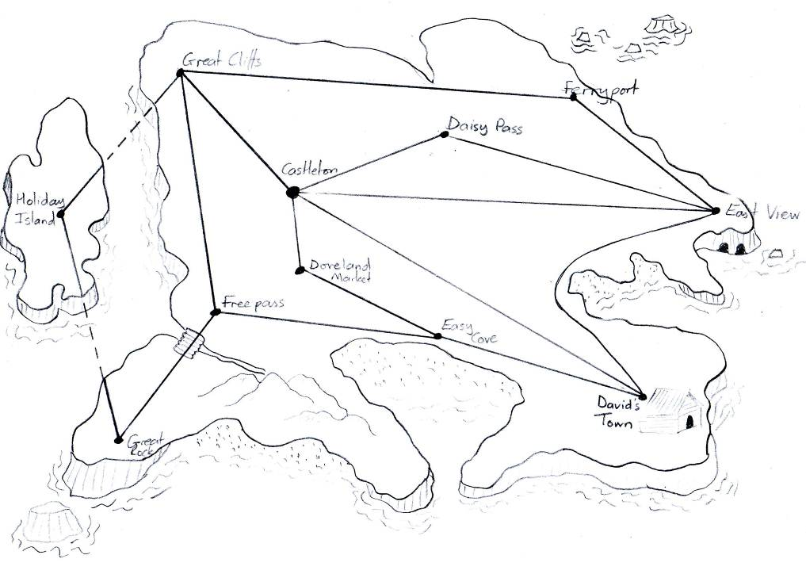
Greycliffs
Castleton
Daisy Pass
Doveland
Market
Ferryport
East View
David’s Town
Freepass
Great Rock
Easy Cove
Holiday
Island
41km
33km
22km
16km
43km
42km
12km
22km
43km
27km
33km
25km
34km
26km
38km
25km
A B C D E F G H I J K L M N O P Q R S T U V W X Y Z
15.2.11

Obj: To solve simple word problems involving measures.

- How far is the journey from Easy Cove to Great Rock?
- How far is the journey from Daisy Pass to Ferry Port?
- How far is the journey from East View to Greycliffs?
- It is possible to reach Holiday Island from Greycliffs and from Great Rock. How much shorter is the journey from Greycliffs?
5) How far is it from Castleton to East View via Daisy Pass?
6) How much longer is this route than the direct route?
7) How far is it from Castleton to East View if I travel through David’s Town?
8) How much further is this route than the direct route?
9) I live in Castleton and I’m going to visit my friend in David’s Town. I need to stop at
Doveland Market on the way. How long will my journey be?
- How much longer is this journey than the direct route?
- Which is the shortest route from Freepass to Holiday Island? How much shorter is this route?
- I need to travel from David’s Town to Greycliffs. There are two different routes. Which route is the shortest? Explain how you know.

Challenge: Pretend you live in David’s Town. Work out how far it is to travel to Holiday Island. Can you work out the total distance for all three different routes? What is the difference between the longest and the shortest route? REMEMBER – The Alphabus service only runs in alphabetical order.

15.2.11

Obj: To solve simple word problems involving measures.
To partition to add.

- How far is the journey from Castleton to East View going through Daisy Pass?

- How far is the journey from Daisy Pass to Ferryport?

- How far is the journey from East View to Greycliffs?

- How far is the journey from Freepass to Holiday Island going through Greycliffs?

- How far is the journey from Freepass to Holiday Island going through Great Rock?

- How far is the journey from Doveland Market to David’s Town?

- How far is the journey from Castleton to Easy Cove?

Challenge: Can you compare these distances?
- How much further is it to go from Castleton to Daisy Pass than it is to go from Castleton to Doveland Market?
- How much shorter is the journey from Freepass to Great Rock than the journey from Freepass to Greycliffs?
- Pretend you live in Castleton. Plan two different journeys to get to Ferryport. How long is each
route?

Notes:

We were doing some work as part of 'Alphabet Week' at school and tried to fit some maths problems in with the theme. As a result I created a map and some word problems linked to measures. The children can only travel around the maps in alphabetical order starting at any point but always moving towards Z from there. (There is a large bus depot for our 'Alphabuses' at the end of each route!!!) Intoduction to the lesson established routes the children could take they then went on to solve the problems.

