9. Miss Jackson needs to replace all the carpet in each of the three bedrooms. The carpet costs £12 per square metre. How much will each bedroom cost me?

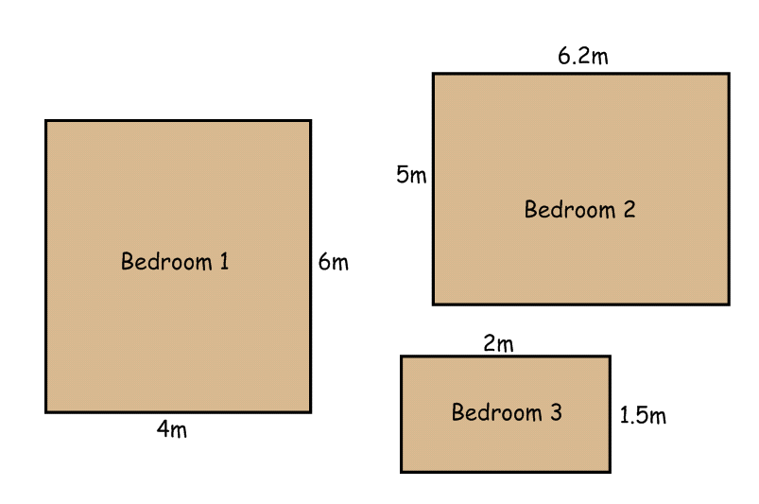
10. Miss Jackson’s bed measures 1.5m by 2m. How big does the mattress have to be?
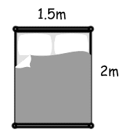

WALT: calculate area and perimeter

1a. Miss Jackson needs to fence her entire garden. Calculate how many metres of fence she will need for each garden.
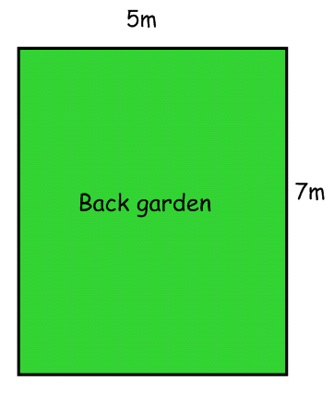
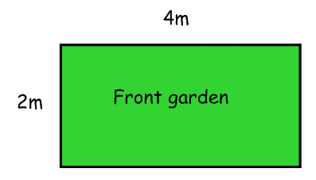

1b. If each metre of fence costs £2. How much will the total cost be?

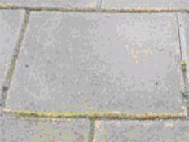
2. Miss Jackson decides to pave her front garden with paving slabs. Each slab is a square metre. How many does she need to buy?

3. If each paving slab costs £3.50. How much will it cost to pave the whole front garden?

4a. Miss Jackson needs to replace all the skirting boards around the living room. How many metres must she buy?
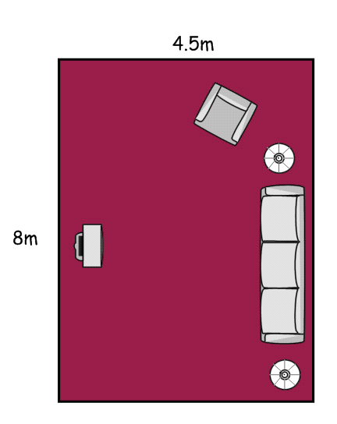

4b. If each metre of skirting board costs £3. How much will it cost for the entire room?

5. She buys 18m of curtain fabric for her 3 windows. 2 windows are 4m wide. What is the width of the remaining window?

6. Miss Jackson spots more fabric in the sale. She buys 2.4m which she cuts into 6 equal lengths for cushion covers. How long will each piece of material be?

7a. Miss Jackson needs to replace all the skirting boards around the living room. How many metres must she buy?
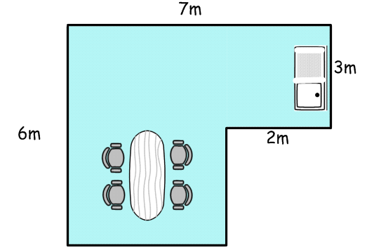

7b. She also decides to change the carpet to laminate flooring. Each square metre of flooring laminate costs £2. How much will it cost?

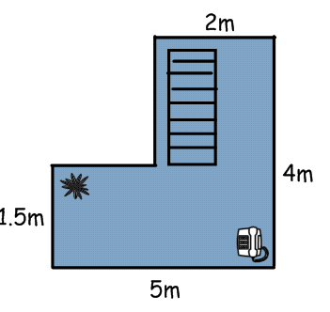
8. Miss Jackson doesn’t like the carpet in the hallway so changes it. How many square metres of carpet does she need?

9. Miss Jackson needs to replace all the carpet in each of the three bedrooms. The carpet costs £12.97 per square metre. How much will each bedroom cost me?

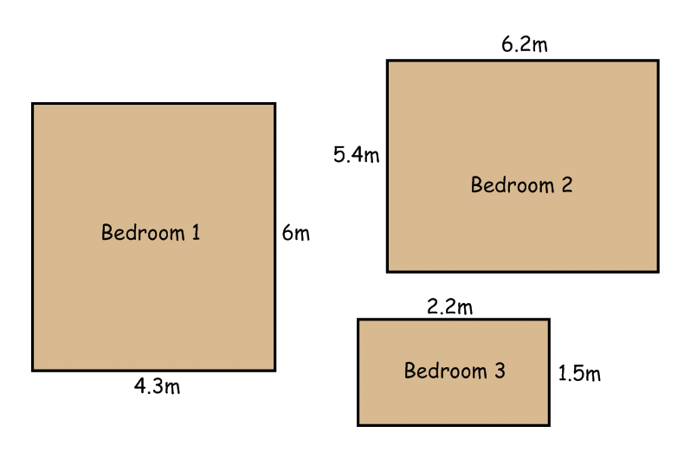
10. Miss Jackson’s bed measures 1.5m by 2m. How big does the mattress have to be?

WALT: calculate area and perimeter

1a. Miss Jackson needs to fence her entire garden. Calculate how many metres of fence she will need for each garden.

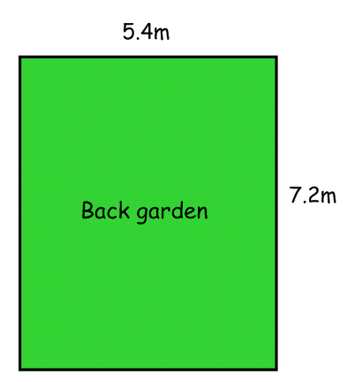
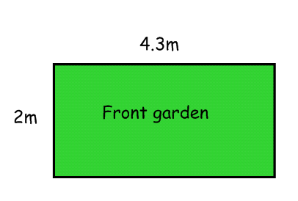

1b. If each metre of fence costs £2.10. How much will the total cost be?

2. Miss Jackson decides to pave her front garden with paving slabs. Each slab is a square metre. How many does she need to buy?

3. If each paving slab costs £3.35. How much will it cost to pave the whole front garden?

4. Miss Jackson needs to replace all the skirting boards around the living room. Each metre costs £1.60. How much will it cost for the entire room?
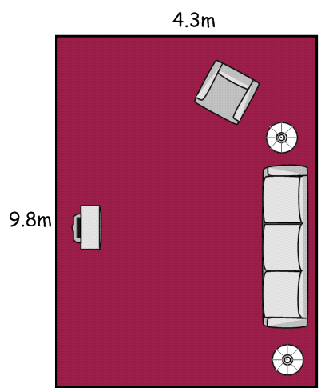

5. Miss Jackson doesn’t like the carpet in the hallway so changes it. How many square metres of carpet does she need?
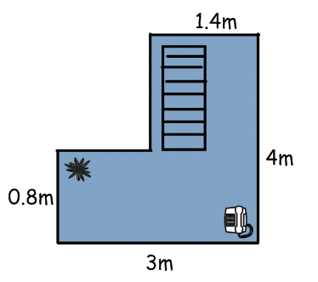

6. She buys 17.3m of curtain fabric for her 5 equal windows. How wide will each piece of material be?

7a. Miss Jackson needs to replace all the skirting boards around the dining room and kitchen as well. How many metres must she buy?
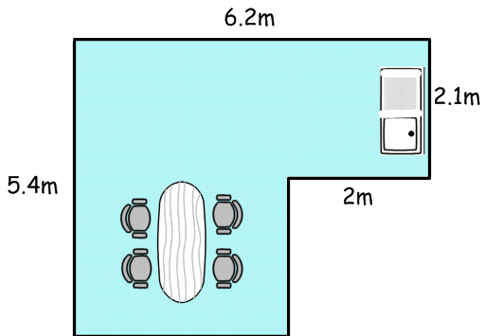

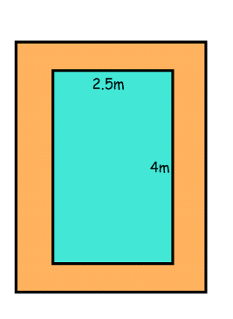
7b. She also decides to change the carpet to laminate flooring. Each square metre of flooring laminate costs £2.45. How much will it cost?

8. Miss Jackson decides to build a swimming pool in her back garden.

The pool measures 4m lengthways by 2.5m wide.

If the path around the pool is 1 metre wide – what is the area of the path?

