Year 4 Area & Perimeter
Name: ………………………………………………………………………
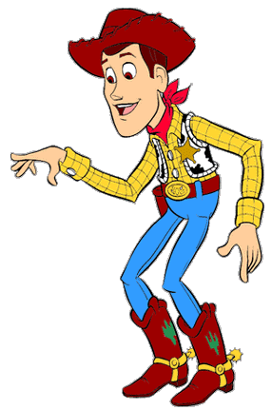
LO: To be able to find the area and perimeter of rectangles and compound shapes.
I need to round up the cows in a pen. Look at these pens. I need to know how long the fence (or perimeter) is and how big they are (or area) to see how many cows they will hold, can you help?

8m
Area: . . . . . . . . . . . . .
Perimeter: . . . . . . . . . . . . .
B)
A)
17m
15m
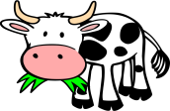
9m

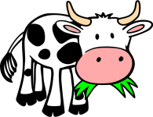
Area: . . . . . . . . . . . . .
Perimeter: . . . . . . . . . . . . .
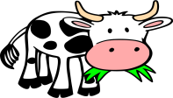
C)
22m
15m
D)

15m
10m

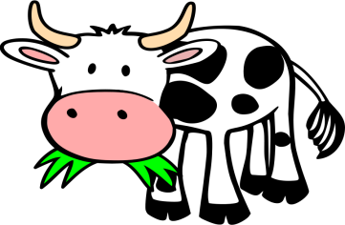
Area: . . . . . . . . . . . . .
Perimeter: . . . . . . . . . . . . .
Area: . . . . . . . . . . . . .
Perimeter: . . . . . . . . . . . . .

F)
Area: . . . . . . . . . . . . .
Perimeter: . . . . . . . . . . . . .
10m
7m
5m
E)
6m
8m
8m
12m
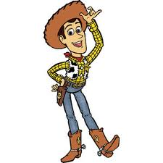
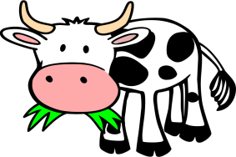
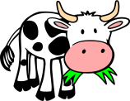
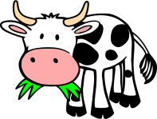
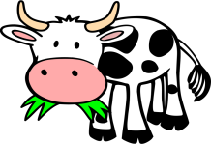
Make sure you include all the measurements. Some are missing!
17m

13m
G)
H)
22m
18m
13m
10m

7m
14m
12m
18m
25m
9m
Area: . . . . . . . . . . . . .
Perimeter: . . . . . . . . . . . . .
Area: . . . . . . . . . . . . .
Perimeter: . . . . . . . . . . . . .
Area: . . . . . . . . . . . . .
Perimeter: . . . . . . . . . . . . .

