WALT- Solve word problems using division. 21st May 09
Simon baked 16 gingerbread men to be shared amongst 4 children. How many did they get each?



Mary cooked 30 cakes for 5 people. How many did they get each?

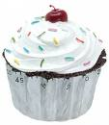
Mary cooked 18 cakes for 3 people. How many did they get each?

Jane ordered 20 cakes and put them on 5 plates. How many on each plate?


Sinead rolled 12 biscuits. She could fit 6 on a tray. How many trays did she need?

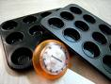

Thomas had 25 muffins to share between 5 of his staff to say thank you. How many did they all get to take home?

