LO – Can I use a calendar?

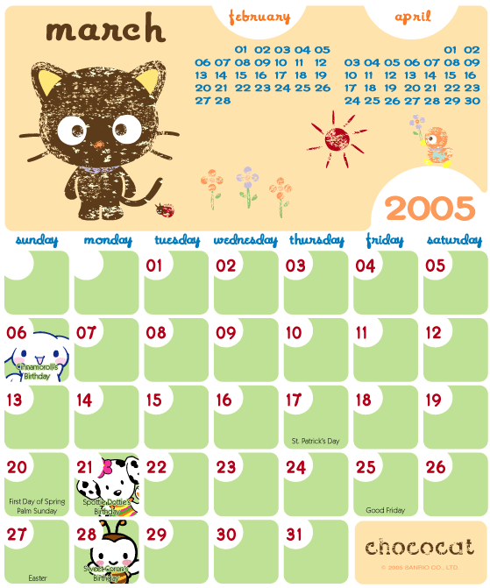

(Please answer in your books)

1. What date is your birthday?

2. What day is your birthday on this year?

3. How many Sundays are there in August?

4.. How many Fridays are there in January?

5.. What special day is 25th March in 2005?

6. How many days are there in July?

7. Which is the shortest month?

8. Which months have 31 days?

9. Which months have 30 days?

10. How many full weeks are there in each month?

11. Using the information on the board, draw a bar graph, showing when our class’ birthdays are.

