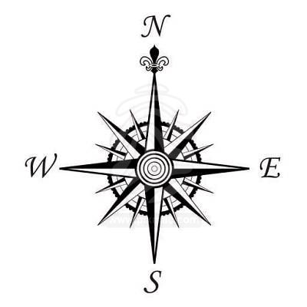
Chessboard Coordinates
WALT: To read and record the movement and direction of objects on a grid
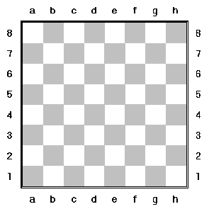
A B

On chessboard A plot the following:
- Put a king (K) on square D2
- Put a bishop (B) on square C7
- Put a queen (Q) on square H5
- Put a knight (N) on square F6
- Put a pawn (P) on square B1
- Put a castle (C) on square G4

On the chessboard plot the final positions of the chess pieces as they have now moved in the following directions:
- K has moved North 2 squares and East 3 squares
- B has moved South 1 square, West 2 squares, South 2 squares and East 1 square
- Q has moved North 3 squares and West 5 squares
- N has moved South 3 squares, West 3 squares and North 4 squares
- P has moved East 6 squares, North 2 squares and West 1 square
- C has moved North 3 squares, West 3 squares, South 5 squares and East 3 squares

Which letters finished in a group of 3? ___________________
Which letters finished in a group of 2? ___________________
Which letter finished in a position by itself? _______________

