12

1
11

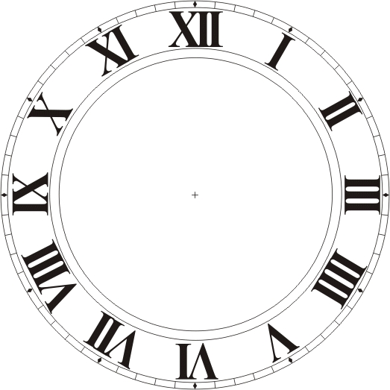
6
5
4
3
2
24
10
9
8
7
13
14
15
16
17
18
19
20
21
22
23

Rules to Time

The large hand on a clock is always the minute hand.
The small hand on a clock is always the hour hand.
Before noon is known as AM and afternoon is known as PM.

