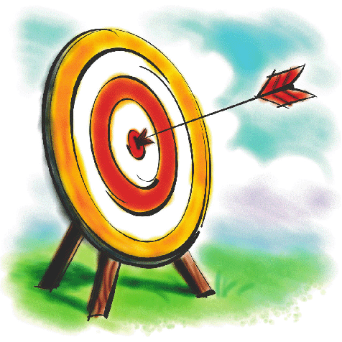
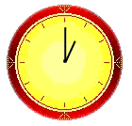
How have these objects turned? Clockwise or anti-clockwise?
Name:
I can recognise a clockwise or anticlockwise turn.


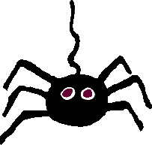
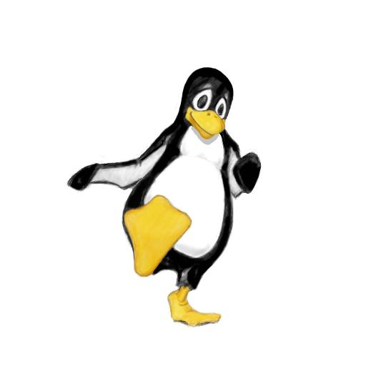


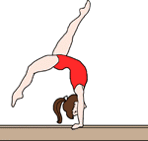
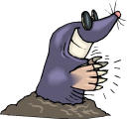

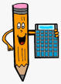
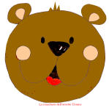
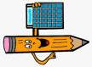
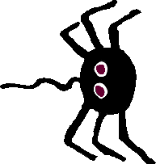
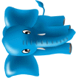
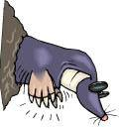
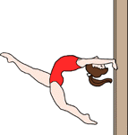
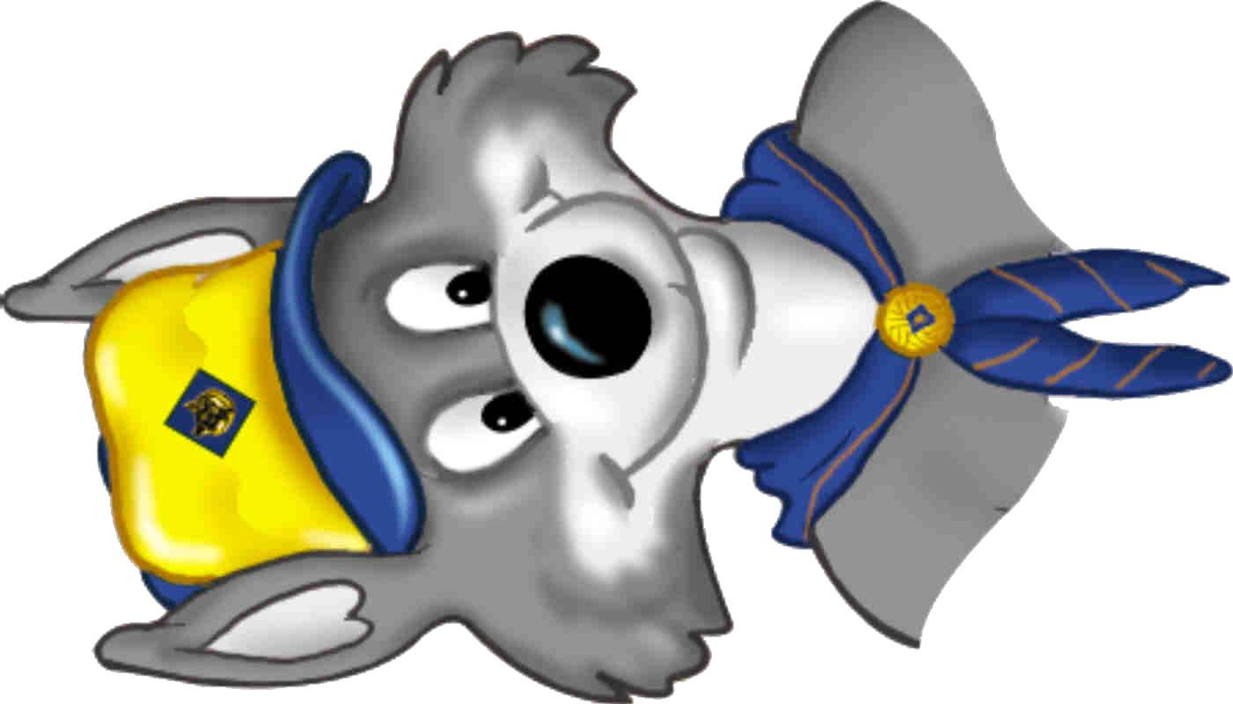
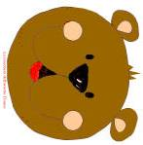
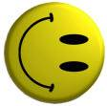
Circle the right answer.
clockwise or anti-clockwise ?
clockwise or anti-clockwise ?
clockwise or anti-clockwise ?
clockwise or anti-clockwise ?
clockwise or anti-clockwise ?
clockwise or anti-clockwise ?
clockwise or anti-clockwise ?
clockwise or anti-clockwise ?
clockwise or anti-clockwise ?
clockwise or anti-clockwise ?
Extension - Which way will these shapes face after they have turned…….

……quarter turn clockwise?
……quarter turn clockwise?

……quarter turn anti-clockwise?
……quarter turn anti-clockwise?
……quarter turn clockwise?
……quarter turn anti-clockwise?
Make a similar question for Mr H!

