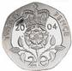 |   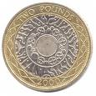 |  | 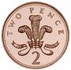
 | 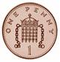 |  | 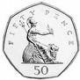
 |  | 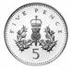
 |  | 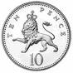

Challenge 1
- Find the total for each row and for each column of coins.
- Write each in answer in 2 ways e.g. £1.99 199p

Challenge 2
- For each of your 10 amounts in Challenge 1, work out the change from £10.00.
- For each amount of change, using the fewest possible notes and/or coins, list the notes and/or coins you would need.

Challenge 3
- Find the total of the complete grid and work out the change from £20.00.

