Coin Grid

Column 1 Column 2 Column 3 Column 4 Column 5

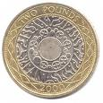

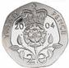
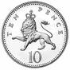
Row 1


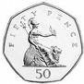
Row 2


Row 3

Row 4

Row 5

