Fold and laminate into playing cards.

1 | 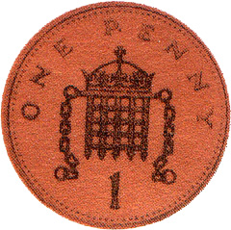  3p
2 | 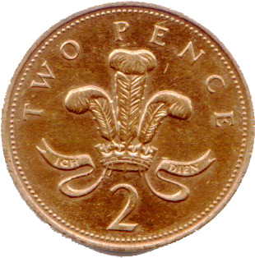  2p
3 | 2p
4 | 1p
5 | 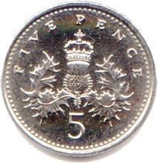  5p
6 | 4p
1 | 1p
2 | 1p
3 | 1p

4 | 1p
5 | 1p
6 | 2p
1 | 3p
2 | 2p
3 | 1p
4 | 2p
5 | 3p
6 | 5p

The children take it in turns to roll the dice and pick up a game card, once all cards are taken they add together their own cards, the child with the most amount wins. Change the amount before printing and copy and paste the coins to your own specification.

Visit the link for more resources.

http://www.jamesstarbuck.com

