Name: _____________________

How Much Money?

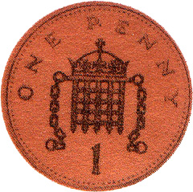
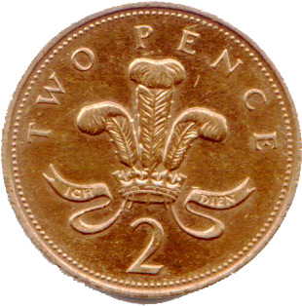
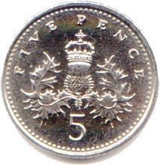

Name: _____________________

How Much Money?

Name: _____________________

How Much Money?

