Can you convert these amounts into pence??
Write your answers in the boxes provided.

1. £3.15 6. £2.22

2. £6.22 7. £9.99

3. £0.86 8. £0.55

4. £5.31 9. £0.12

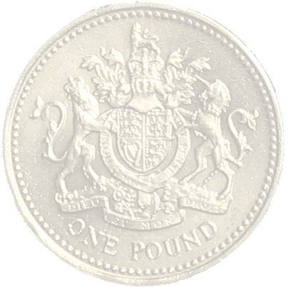

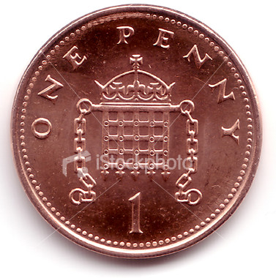
5. £0.11 10. £0.05

