How much in my piggy bank?

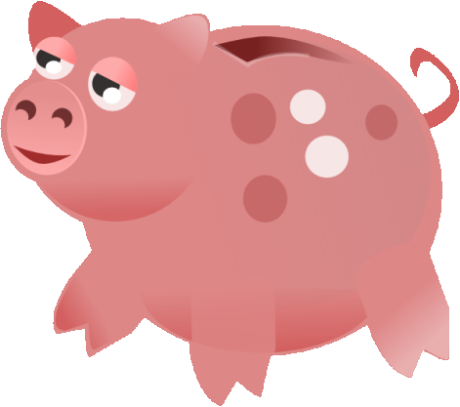  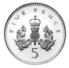  __p | __p
__p | __p
__p | __p
__p | __p

