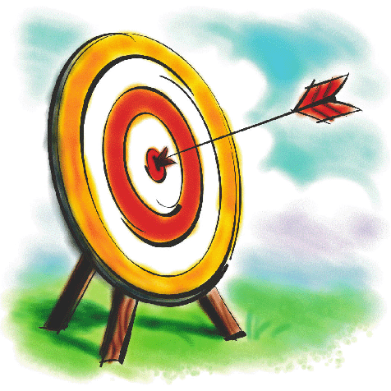
Name:
I can count forwards and backwards to 50.

Name:
I can count forwards and backwards to 100.

