______________________

I can count on and back in steps of 1 and 10

Can you complete the following sequences?

21 | 22 | 23 |  |  |  |  | 10 | 20 | 30

37 | 38 | 39 |  |  |  |  | 50 | 60 | 70

69 | 70 | 71 |  |  |  |  | 21 | 31 | 41

 |  |  | 45 | 46 | 47 |  | 46 | 56 | 66

 |  |  | 39 | 40 | 41 |  |  |  |  | 35 | 45 | 55

 |  |  | 80 | 81 | 82 |  |  |  |  | 69 | 79 | 89

97 | 98 | 99 |  |  |  |  | 66 | 76 | 86

111 | 112 | 113 |  |  |  |  |  |  |  | 100 | 110 | 120

Now make up your own sequence counting on in 1s.
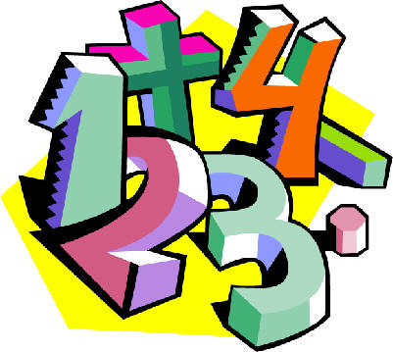
Can you count back in 1s from and 2-digit number?

