Can you label this picture of a cube?
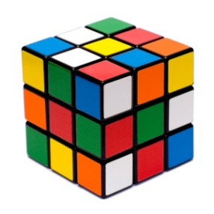

Vertex (or corner) Edge (or side) Face
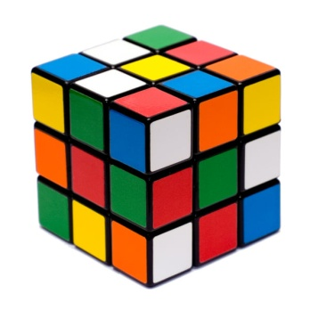
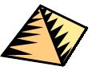
Investigation: Can you find out how many vertices, edges and faces the following 3D shapes have?
A Cube
Vertices:
Edges:
Faces:

A Cuboid
Vertices:
Edges:
Faces:

A Pyramid
Vertices:
Edges:
Faces:

A Cylinder
Vertices:
Edges:
Faces:

A Cone
Vertices:
Edges:
Faces:

A Sphere
Vertices:
Edges:
Faces:

3D Shape Treasure Hunt
Can you find the following shapes in the playground?
Take a photo – first group back to the classroom wins!
A Cylinder
A Cube
A Sphere
A Cuboid

