Fractions and Decimals
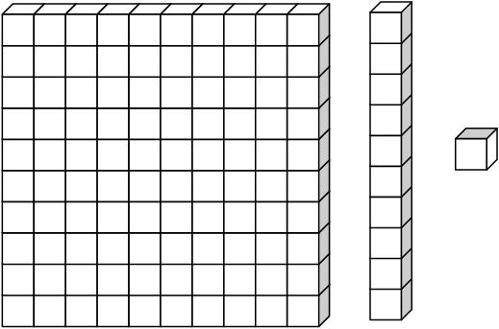

One whole. One tenth One hundredth

H | T | U |  | t | h
Hundreds | Tens | Units | Decimal point | tenths | hundredths

Write the following as a fraction and a decimal.

1. 2.

3. 4.

5. 6.

7. 8.

9. 10.

