O
I shared 16 buttons between 4 coats. How many buttons are there on each coat?
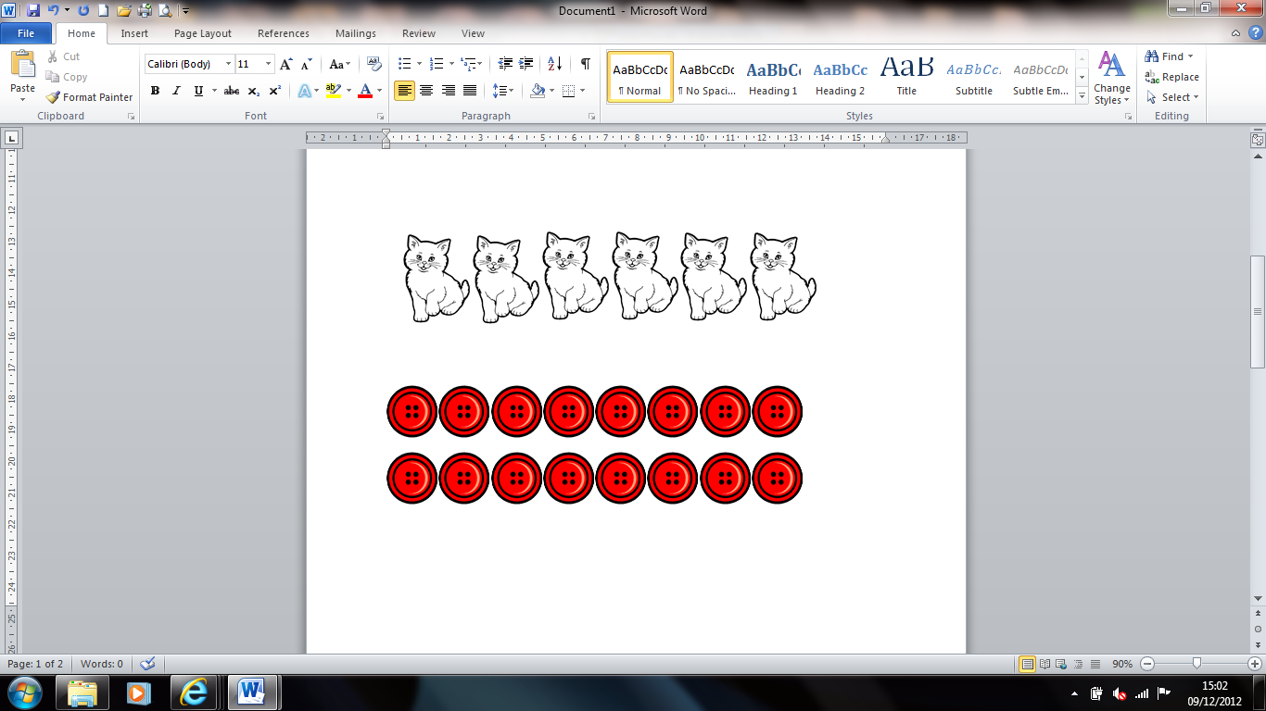

How many wheels are there on 3 cars?



Tanya shares 12 cakes between her 3 friends. How many cakes do her friends get each?
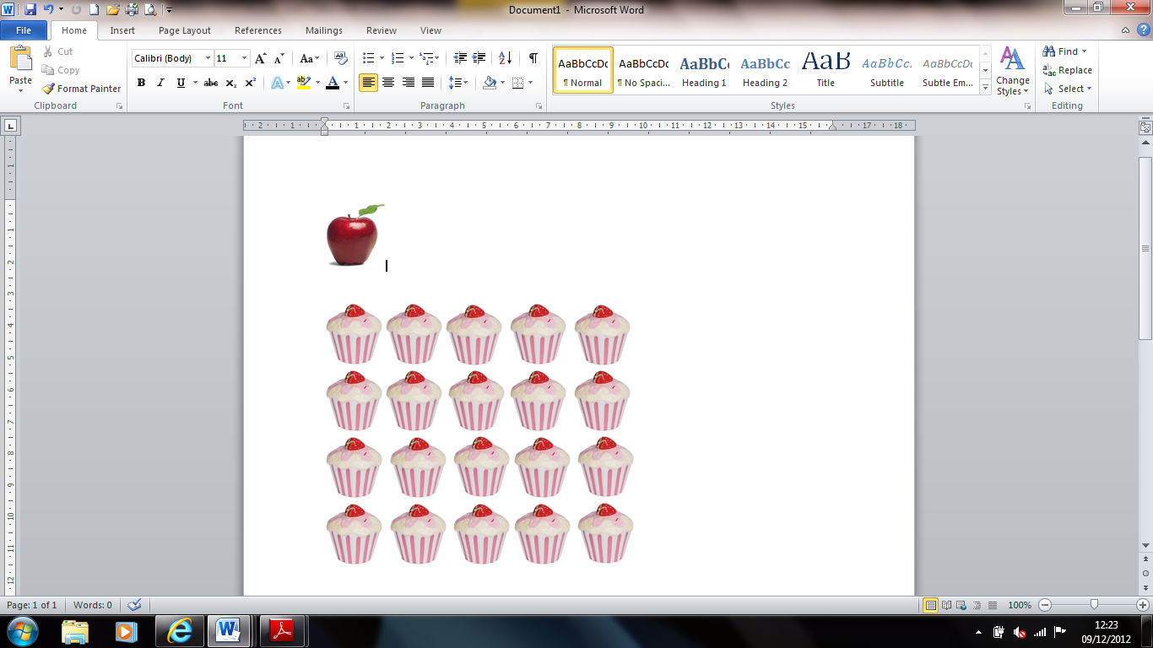
There are 4 apples in each pack. Mr Brown buys 2 packs of apples. How many apples does he buy?
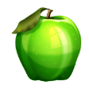

Ella shares 15 carrots between her 3 rabbits. How many carrots do her rabbits get each?
There are 2 pencils in each pack. Bella bought 5 packets. How many pencils does she buy?
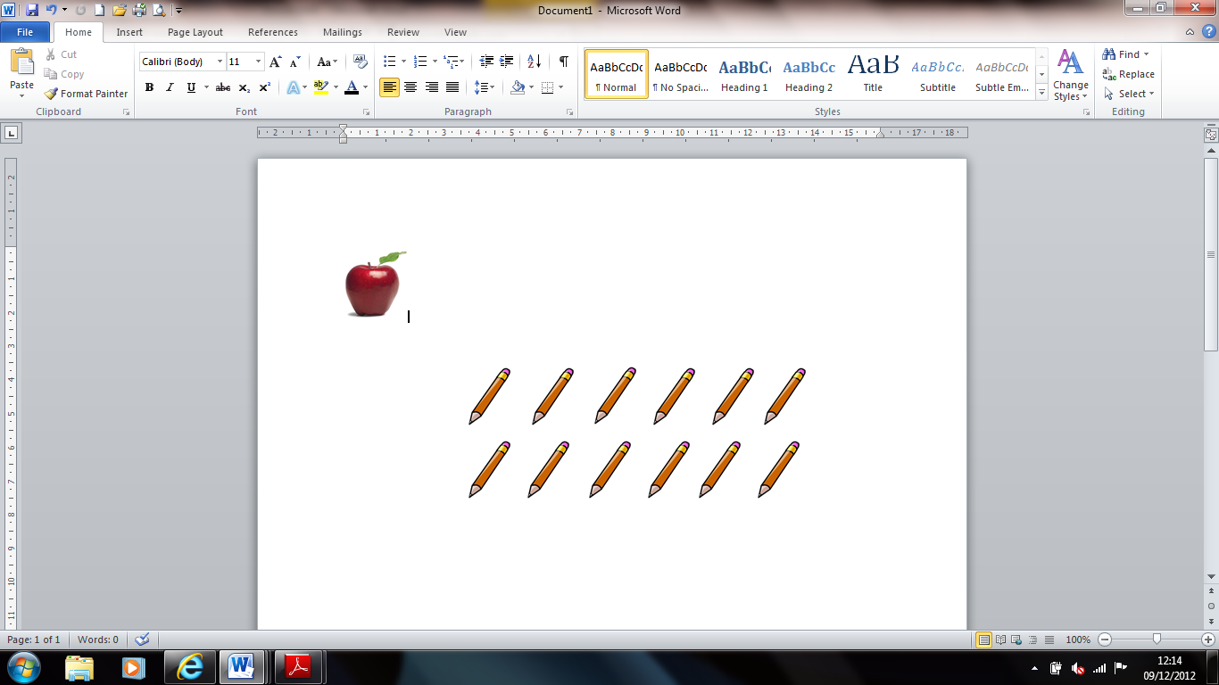

G
I shared 30 buttons between 6 coats. How many buttons are there on each coat?
How many wheels are there on 7 cars?




Tanya shares 24 cakes between her 6 friends. How many cakes do her friends get each?
There are 7 apples in each pack. Mr Brown buys 6 packs of apples. How many apples does he buy?
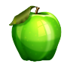

Ella shares 27 carrots between her 3 rabbits. How many carrots do her rabbits get each?
There are 6 pencils in each pack. Bella bought 4 packets. How many pencils does she buy?
There are 5 sharpeners in each pack. Jack bought 4 packets. How many pencils does he buy?

B
I shared 35 buttons between 7 coats. How many buttons are there on each coat?
How many wheels are there on 9 cars?

Tanya shares 42 cakes between her 6 friends. How many cakes do her friends get each?

There are 8 apples in each pack. Mr Brown buys 9 packs of apples. How many apples does he buy?
Ella shares 32 carrots between her 8 rabbits. How many carrots do her rabbits get each?

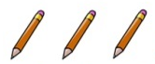
There are 9 pencils in each pack. Bella bought 5 packets. How many pencils does she buy?
There are 6 sharpeners in each pack. Jack bought 10 packets. How many pencils does he buy?

Y
I shared 56 buttons between 7 coats. How many buttons are there on each coat?
How many wheels are there on 12 cars?

Tanya shares 72 cakes between her 8 friends. How many cakes do her friends get each?
There are 8 apples in each pack. Mr Brown buys 11 packs of apples. How many apples does he buy?
Ella shares 63 carrots between her 9 rabbits. How many carrots do her rabbits get each?

There are 9 pencils in each pack. Bella bought 10 packets. How many pencils does she buy?
There are 7 sharpeners in each pack. Jack bought 12 packets. How many pencils does he buy?

