Division with remainders
(Amethysts and Diamonds)

You can get 2 people in a boat. There are five people. How many boats will you fill and how many people will be left over?

5 ÷ 2 = _____

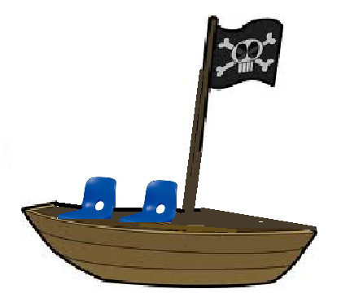

You can get 2 people in one boat. There are 9 people. How many boats can you fill and how many people will be left over?

9 ÷ 2 = _____

Now try these:

A, 7 ÷ 2 = ____

B, 11 ÷ 2 = ____

C, 5 ÷ 2 = ____

D, 13 ÷ 2 = ____

E, 15 ÷ 2 = ____
F, 23 ÷ 10 = ____

G, 15 ÷ 10 = ____

H, 24 ÷ 10 = ____

I, 35 ÷ 10 = ____

J, 42 ÷ 10 = ____

K, 54 ÷ 10 = ____

Division with remainders
(Sapphires)

You can get 2 people in a boat. There are 21 people. How many boats will you fill and how many people will be left over?

11 ÷ 2 = _____

Now try these:

A, 13 ÷ 3 = ____

B, 13 ÷ 2 = ____

C, 17 ÷ 3 = ____

D, 26 ÷ 5 = ____

E, 32 ÷ 5 = ____

F, 44 ÷ 5 = ____

G, 27 ÷ 2 = ____

H, 19 ÷ 3 = ____

I, 22 ÷ 10 = ____

J, 34 ÷ 10 = ____

K, 43 ÷ 10 = ____

L, 55 ÷ 10 = ____

M, 66 ÷ 10 = _____

N, 72 ÷ 10 = _____

Division with remainders
(Rubies and Emeralds)

You can get 2 people in a boat. There are 21 people. How many boats will you fill and how many people will be left over?

11 ÷ 2 = _____

Now try these:

A, 17 ÷ 3 = ____

B, 26 ÷ 5 = ____

C, 32 ÷ 5 = ____

D, 44 ÷ 5 = ____

E, 17 ÷ 4 = ____

F, 22 ÷ 4 = ____

G, 25 ÷ 4 = ____

H, 33 ÷ 4 = ____

I, 35 ÷ 4 = ____

J, 39 ÷ 5 = ____

K, 37 ÷ 4 = ____

L, 28 ÷ 3 = ____

M, 29 ÷ 4 = ____

N, 31 ÷ 4 = ____

O, 30 ÷ 4 = ____

P, 99 ÷ 10 = ____

Q, 103 ÷ 10 = ____

R, 112 ÷ 10 = ____

