Double and Half

Draw the spots on the butterfly and complete the sentence below each one.

Double 3 is ___ Double 8 is ___ Double 6 is ___ Double 10 is ___

Double 7 is ___ Double 9 is ___ Double 5 is ___ Double 4 is ___

Draw the candles on the cakes, sharing them equally on each half and complete the sentences below each one.

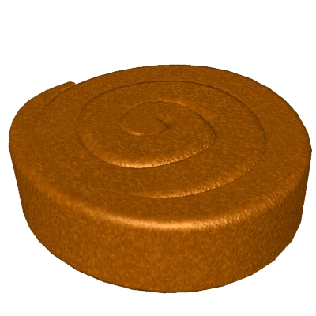
Half of 8 is ____ Half of 2 is ___ Half of 10 is ___

Half of 12 is ____ Half of 6 is ___ Half of 14 is ___

Half of 4 is ____ Half of 18 is ___ Half of 16 is ___

