  1 + 1 = |   2 + 2 =
  3 + 3 = |   4 + 4 =
  5 + 5 = |   6 + 6 =
  7 + 7 =  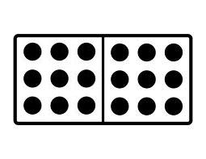 | 8 + 8 =
9 + 9 = |   10 +10=
I know my doubles facts!
1 + 1 = _____ 6 + 6 = _____

2 + 2 = _____ 7 + 7 = _____

3 + 3 = _____ 8 + 8 = _____

4 + 4 = _____ 9 + 9 = _____

5 + 5 = _____ 10 + 10 = _____

